LET US CONNECT
SOLAR GENERATION
WITH
MEPCO NETWORK
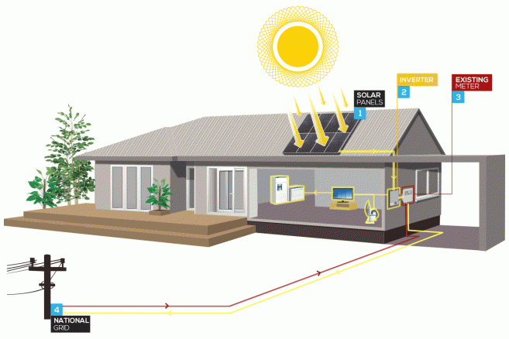

CUSTOMER SERVICES DIRECTORATE
(MEPCO NET METERING CELL)
SEPTEMBER, 2018
NOTE: Agricultural Consumers are also allowed to convert their solar system in MEPCO Net Metering Connections 
TABLE OF CONTENTS
 | Sr. No. |  |  |  | DESCRIPTION |  |  |  |  | PAGE NO.
1. |  |  |  | CHECKLIST FOR FILING NET METERING APPLICATIONS |  |  |  |  | 4-5
2. |  |  |  | APPLICATION FORM |  |  |  |  | 6-19
 |  |  |  |  | ➢ | Schedule-I |  |  | 7-11
 |  |  |  |  | ➢ | Schedule-II |  |  | 12-14
 |  |  |  |  | ➢ | Schedule-III |  |  | 15
 |  |  |  |  | ➢ | Schedule-IV |  |  | 16
 |  |  |  |  | ➢ | Schedule-V |  |  | 17
 |  |  |  |  | ➢ | Schedule-VI |  |  | 18
 |  |  |  |  | ➢ | Schedule-VII |  |  | 19
3. |  |  |  | MEPCO SOP |  |  |  |  | 20-26
 |  |  |  |  | ➢ | Registration of Application |  |  | 21
 |  |  |  |  | ➢ | Application Processing |  |  | 22
 |  |  |  |  | ➢ | Some important pre-requisites |  |  | 23
 |  |  |  |  | ➢Distributed Generation Facility Design and Operating Requirements |  |  |  | 24
 |  |  |  |  | • | Single Line Diagram |  |  | 25
 |  |  |  |  | • | Earthing Protection |  |  | 25
 |  |  |  |  | • | Equipment earth (DC) |  |  | 25
 |  |  |  |  | • | System earth (AC) |  |  | 25
 |  |  |  |  | • | Surge Protection |  |  | 25
 |  |  |  |  | ➢ | Periodical inspections |  |  | 25
 |  |  |  |  | ➢ | Billing procedure |  |  | 25-26
 |  |  |  |  | ➢ | General Guidelines |  |  | 26
4. |  |  |  | NEPRA REGULATIONS |  |  |  |  | 27-39
5. |  |  |  | - SRO No. 1025(I)2017 10-10-2017.PDF  - Amendments in Net Metering SRO No.1261(I)2017  - NEPRA NOTIFICATION-SRO No.-892-2015  SINGLE LINE DIAGRAM |  |  |  |  | 40-41
6. |  |  |  | FLOW CHART AND STEPS OF INTERCONNECTION PROCESS |  |  |  |  | 42-43
7. |  |  |  | TECHNICAL FEASIBILITY, TEST CHECK & INSPECTION |  |  |  |  | 44-48
 |  |  |  | PROFORMAS
 |  |  |  |  | o Solar Net Metering Technical Feasibility Report |  |  |  | 45
 |  |  |  |  | o Inspection / Test Check Performa |  |  |  | 46
 |  |  |  |  | o Sample Specifications of Solar Grid Inverter for Guidance Purpose |  |  |  | 47
 | 8. |  |  |  | o Checklist for Solar Rooftop PV Grid Safety Qualification AEDB Approved Vendors List |  |  |  | 48  49-54
09.  10. |  |  |  | INSPECTION OF ELECTRICAL INSTALLATIONS  CONTACT DETAILS |  |  |  |  | 55-57  58
11. FAQ (Frequently Asked Questions) about Net Metering 59-66
in MEPCO 25-04-2018

CHECKLIST FOR FILING

NET METERING APPLICATIONS



CHECKLIST FOR FILING NET METERING APPLICATIONS
- Upgrade your Connection Type: 3 Phase & Sanctioned Load must be equal or Greater than load applied for DG Facility
- Distributed Generation Interconnection Agreement between Distributed Generator and Distribution Company (Schedule-I)

- Standard Distributed Generation Application Form For Distribution Company (Schedule-II)

- Application for grant of License National Electric Power Regulatory Authority (NEPRA) (Schedule-III

- Application for Exemption from section 24 of the Act (Schedule-IV)

- Fee Schedule (Schedule-V)

- Affidavit(On non-judicial paper) (Schedule-VI)

- Generation License Template (Schedule-VII)

- Attested copy of CNIC.

- Copy of last paid electricity bill. (Name of applicant and name mentioned on electricity bill must be same).

- Technical Data of components including solar modules, invertors, etc.
- Schematic drawings, Single line diagram of the system

- Site plan showing location of external disconnect switch.

- Certificate from Electrical Inspector if DG facility is Above 250 KW.
- Load Flow Study if DG Facility is greater than 250 KW (as per AEDB Policy).
- Inspection of Electrical Installations from Installer/ AEDB approved Vendor.
NOTE: -
i. a) Only consumers having 3 phase meters installed at their premises are eligible for net metering facility.
b) Sanctioned Load of Consumer must be equal or greater than load applied for DG Facility
ii. The inverters must be of grid-tied type.
iii. Maximum allowed capacity for net metering facility is 1000 KWs.
iV. Inspection of electrical installations for Commissioning / Energization for inter connection of D.G. Facility with the distribution system of
disco for net-metering is also required from installer/AEDB approved vendors.
For Further details please visit :
- http://www.mepco.com.pk/Net-Metering-MEPCO
- http://www.nepra.org.pk/Legislation/Regulations/NOTIFICATION%20SRO%20892%20-2015.PDF
- http://www.nepra.org.pk/Lic_netmetering.htm
- http://www.aedb.org/articles-list/268-list-of-provisionally-approved-applicants-for-net-metering-under-aedb-certification-regulation-2017
http://www.aedb.org/ju-elibrary/distributed-generation /net-metering-reference-guide-for-the-discos
***************************************************************
Comments / Suggestions (if any) may be communicated through:
Email ID:powersystempk@gmail.com
Phone No.: 0330-8088418
***************************************************************
Compiled by: Muhammad Rehan Khan (Addl. A.M Computer Operations)0333-6175707, 0302-7475120, 0312-9659359
***************************************************************

NET METERING

APPLICATION FORM


SCHEDULE

I TO VII

Schedule-I

[See Regulation 2 (1) (b)]

Distributed Generation Interconnection Agreement (1 KW to 1 MW) between

Distributed Generator and Distribution Company

The Distributed Generation Interconnection Agreement (the “Agreement”), is made and entered in to this _________________ (day) of _________________ (month), ________________ (year) by and between MULTAN ELECTRIC POWER COMPANY (MEPCO) hereinafter called “DISCO” and

______________________________________ hereinafter called the “Applicant”. Applicant shall be 3 phase 400 V or 11 kV DISCO’s consumer. DISCO and the Applicant are hereinafter collectively referred to as the “Parties” and individually as a “Party”.

Recitals

A. DISCO is the owner of the electric distribution system serving

_____________________________________________ [Insert legal description of property or address] “DISCO’s Distribution System”

- Applicant desires to install a Distributed Generator (DG) facility or energy storage device using solar or wind energy resources with a capacity greater than 1 KW but no more than 1

MW, including related Interconnection equipment (the “DG facility”) and to interconnect the DG facility to the DISCO’s Distribution System.

- DISCO has previously reviewed and approved Applicant’s DG Interconnection Applicant Form dated_______________, and supporting materials (the “Application”). The completed Application is attached as Exhibit 1 and incorporated into this Agreement.

- Applicant wishes to interconnect the DG Facility to DISCO’s distribution system and DISCO is willing to permit such interconnection subject to the terms and conditions set forth: (1) the completed Application approved by DISCO; (2) this Agreement

- No agency or partnership is created with the interconnection of the applicants DG Facility.

Agreement

NOW THEREFORE, in consideration of the foregoing Recitals and for good and valuable consideration, the DISCO and Applicant agree as follows:

1. Design Requirement

The DG Facility shall be installed in compliance with NEPRA (Alternative & Renewable Energy) Distributed Generation/ Net Metering Regulations 2015.

2. Applicant’s Representations and Warranties

Applicant represents and warrants that:

- The DG Facility is fully and accurately described in the Application;
- All information in the Application is true and correct;
- The DG Facility has been installed to Applicant’s satisfaction;

- Applicant has been given warranty information and an operation manual for the DG Facility;

- Applicant has been adequately instructed in the operation and maintenance of the DG Facility.

3. Interconnection Disconnect Switch

The DISCO may require that the Applicant furnish and install an interconnection disconnect switch that opens, with a visual break, all underground poles of the interconnection circuit. The interconnection disconnect switch shall be rated for the voltage and fault current requirements of the DG Facility, and shall meet all the applicable IEC, IEEE Standards, as well as applicable requirements of the NEPRA Grid Code. The switch enclosure shall be properly grounded. The interconnection disconnect switch shall be accessible at all times, located for ease o access of DISCO personnel, and shall be capable of being locked in the open position. The Applicant shall follow the DISCO’s recommended switching, clearance, tagging and locking procedures.

4. Modifications to the DG Facility

Applicant shall notify DISCO of plans for any material modification to the DG Facility by providing at least forty working days of advance notice. “Material Modification” is defined as any modification that changes the maximum electrical output of the DG Facility or changes the interconnection equipment. The notification shall consists of a completed, revised Application and such supporting materials as may be reasonably requested by DISCO. Applicant agrees not to commence installation of any material modification to the DG Facility until DISCO has approved the revised Application.

5. Insurance, Indemnification, Liability

5.1 Distributed Generator shall obtain and maintain appropriate insurance for third party personal injury and general commercial liability.

5.2 Each party as inseminator shall defend, hold harmless, and indemnify the other party and the directors, officers, employees, and agents of the other party against and from any and all loss, liability, damage, claim, cost, charge, demand, or expense (including any direct, indirect or consequential loss, liability, damage, claim, cost, charge, demand, or expense, including attorney’s fees) for injury or death to persons, including employees of either party, and damage to property, including property of either party, arising out of or in connection with

- the engineering, design, construction, maintenance, repair, operation, supervision, inspection, testing, protection or ownership of the inseminator's facilities, or (b) the making of replacements, additions, betterments to, or reconstruction of the inseminator's facilities.

This indemnity shall apply notwithstanding the active or passive
indemnities. However, neither party shall be indemnified hereunder for its loss, liability, damage, claim, cost, charge, demand, or expense resulting from its sole negligence or wilful misconduct.

5.3 The inseminator shall, on the other party’s request, defend any suit asserting a claim covered by this indemnity and shall pay for all costs, including reasonable attorney fees that may be incurred by the other party in enforcing this indemnity.

5.4 The provisions of this Section shall not be construed to relieve any insurer of its obligations to pay any insurance claims in accordance with the provisions of any valid insurance policy.

5.5 Except as otherwise provided in this section, neither party shall be liable to the other party for consequential or remote damages incurred by that party.

6. DG Facility Commissioning Testing

Applicant shall notify DISCO in writing that installation of DG Facility is complete and that the interconnection equipment is available for testing by DISCO at least fifteen working days duly certified by Electrical Inspector before Applicant interconnects the DG Facility with DSICO’s Distribution System. DISCO shall thereupon have the right to test the DG Facility. DISCO shall also have the right to witness any testing by Applicant of the DG Facility. Any DISCO testing of the DG Facility shall be completed within ten working days. After the testing which is to the satisfaction of both parties, the DG facility may be interconnected with the distribution system of DISCO to be witnessed by representatives of both parties within thirty eight days.

7. Access to DG Facility

Applicant shall permit DISCO’s employees and agents to enter the property on which the DG Facility is located at any reasonable time for the purposes of inspecting and/or testing Applicant’s DG Facility to ensure its continued safe and satisfactory operation and the accuracy of DISCO meters. Such inspections shall not relieve Applicant from its obligation to maintain the DG Facility and any related equipment owned by Applicant in safe and satisfactory operating conditions.

DISCO shall have the right to witness any testing by Applicant of the DG Facility.

8. Temporary Disconnection of a DG Facility

DISCO may limit the operation and/or disconnect or require the disconnection of a DG Facility from DISCO’s Distribution System at any time, with or without notice, in the event of fault. DISCO may also limit the operation and/or disconnect or require the disconnection of DG Facility from DISCO’s Distribution System upon the provision of thirty days written notice for the conditions to allow for routine maintenance, repairs or modifications to DISCO’s Distribution System.

9. Disputes; Right to Appeal to Authority

Nothing in this Agreement prevents Applicant from filing a petition with the Authority to appeal any requirement imposed by DISCO as a condition to interconnection of DG Facility that applicant
alleges is unreasonable. In case of a dispute, the decision of the Authority shall be final and binding on both the parties.

10. Amendments; Non-Waiver

Any amendment or modification to this Agreement must be in writing and executed by Applicant and DISCO. The failure of Applicant or DISCO to insist on performance by the other party of any provision of this Agreement shall not waive the right of the Party who failed to insist on performance to enforce the same provision at a later time.

11. Term and Termination of Agreement

The term of Agreement between Distributed Generator and DISCO shall be three years with effect from the date of commissioning of DG facility. At the expiry of initial term, the Agreement may be automatically renewed by the mutual understanding between Distributed Generator and DISCO for another term of three years and so on.

- DISCO may limit the operation and/or disconnect or require the disconnection of a DG

Facility from DISCO’s Distribution System at any time, with or without notice, in the event of fault. DISCO may also limit the operation and/or disconnect or require the disconnection of DG Facility from DISCO’s Distribution System upon the provision of thirty days written notice for the conditions which including as follows:

  - To allow for routine maintenance, repairs or modifications to DISCO’s Distribution

System

  - Upon DISCO’s determination that DG Facility is not in compliance with these Rules

  - Upon termination of the Agreement

- This Agreement may be terminated in accordance with these Regulations

- The Distributed Generator may terminate the Agreement upon thirty days written notice if the Distributed Generator determines to discontinue the sale of electricity to the DISCO

- The DISCO shall not terminate the Agreement in any event without prior approval of the Authority

- All rights and obligations accrued up to termination shall continue in force upon termination

12. Successors and Assigns

- Assignment by Applicant: Applicant shall not assign its rights and obligations under this Agreement in whole or in part without the prior written consent of DISCO, which consent shall not be unreasonably withheld or unduly delayed. DISCO may withhold its consent to any proposed assignment if the proposed assignee fails to assume the obligations of Applicant under this Agreement in writing.

- Assignment by DISCO: The DISCO shall have the right to assign this agreement in whole upon written notification to the Applicant.

- Successors: This Agreement shall be binding upon the personal representatives, heirs, successors and permitted assigns of the respective Parties.
13. Applicant and DISCO Signature and Seal

IN WITNESS WHEREOF, Applicant and DISCO have executed this Agreement as of the year and date first set forth above.

Applicant Signature & Date DISCO’s Signature with Seal & Date

Title Title

Witness No. 1 (Name & Signature) Witness No. 1 (Name & Signature)

Witness No. 2 (Name & Signature) Witness No. 2 (Name & Signature)

Schedule-II

[See Regulation 3(1)]

Standard Distributed Generation Application Form for Distribution Company

 | Distributed by |  |  | Approved by
Name & Address of DISCO
 | MULTAN ELECTRIC POWER COMPANY (MEPCO) |  |  | National Electric Power Regulatory Authority
 | KHANEWAL ROAD , MULTAN |  |  | (NEPRA)

Contact Information—The applicant is the person that is legally responsible for the generation system 

Applicant’s Last Name First Name

CNIC of Applicant/CUIN in case of Company (copy to be attached)

Applicant’s Mailing Address

Applicant’s Phone Number & Email Address

Office:- | Fax:-
Cell:- | Email:-

Emergency Contact Numbers

Location of Generation System

Address at which DG facility is located

Latitude-Longitude (i.e. 49º 32"N 91o 64’ 18” optional)

Applicant/Consumer Reference Number

Applicant’s Ownership Interest in the Generation System

 |  |  | Owner |  | Co-owner |  | Lease |  | Other ____________

Primary Intent of the Generation System
Sstem

Onsite Use of Power |  | Net Energy Billing

Electricity Use, Production and Purchases

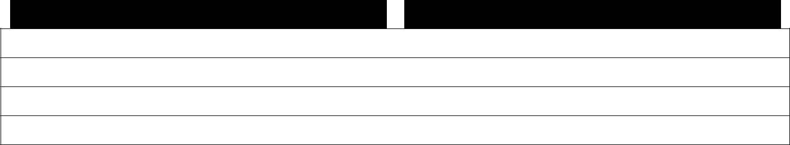
- Anticipated annual electricity consumption of the facility or site: (KWh)/yr.

- Anticipated annual electricity production of the generation system: (KWh)/yr.

- Anticipated annual electricity purchases (i.e., (a) minus (b) (KWh)/yr.

"Value will be negative if there are net sales to the DISCO.”

Installing Contractor Information (If Applicable)
Contractor’s Last Name First Name

Name of Firm

Contractor’s Phone Number Email Address

Mailing Address

Requested In-Service Date

Provide One-Line Schematic Diagram of the System

 |  |  | Schematic is attached |  |  |  |  |  |  |  | Number of Pages
 |  | Generator/Inverter Information
 | Manufacturer |  |  |  |  |  |  |  |  | Model No
 | Version No. |  |  |  |  |  |  |  |  | Serial No.
 | Generation Type (Check one) |  |  |  |  |  |  |  |  | Generation Type (Check one)
 |  |  | Three Phase |  | Single Phase |  |  |  |  |  | Inverter |  |  | Other __________
 |  | Name Plate AC Ratings (Check one)
 |  |  | _________ KW |  | ____ KVA |  |  |  |  |  | ____________ volts
 | Primary Energy Source

Note:- If there is more than one inverters, attach an additional sheet describing each


Site Plan Showing Location of the External Disconnect Switch (attach additional sheets as needed)



Design Requirements


(a) Has the proposed distributed generation paralleling equipment been certified by

Electrical inspector? |  | Y |  | N


Other Comments, Specification and Exceptions (attach additional sheets if needed)

Applicant and Installer Signature

To the best of my knowledge, all the information provided in this application form is completed and correct.

Applicant Signature Date

Installer Signature (if applicable) Date

Schedule-III

[See Regulation 4(2)]

APPLICATION FOR GRANT OF LICENSE

NATIONAL ELECTRIC POWER REGULATORY AUTHORITY (NEPRA)

1. Name of Applicant:

1. (a)CNIC of

Applicant/CUIN in case of

Company (Copy to be attached)

1. (b) Address:

1. (c) Contact No's:

Office______________________ Fax ____________________

Cell ________________________

1. (d) Email Address:

2.Location of DG facility:

3. Name of DISCO with which

the DG facility is proposed to be

Interconnected

4. Size of

DG facility:

5. Approximate monthly energy

proposed to be supplied to

DISCO (KWh):

6. Fee to be deposited:

(Non-Refundable)

Applicant’s Signature

Date

Schedule -IV

[See Regulation 4(2) (b)]

Application for Exemption from section 24 of the Act

I/we ___________________________________________________________ for the purposes of grant of License of Distributed Generator under NEPRA (Alternative & Renewable Energy) Distributed Generation/Net Metering Regulations 2015 hereby request the Authority for grant of exemption from the requirement of being registered as a company under the Companies Ordinance, 1984 (XLVII of 1984) under section 24 of the Act.

Name and Address of Distributed Generator:

Stamp

Schedule -V

[See Regulation 4(2) (c)]

Fee Schedule

A Distributed Generator shall be bound to pay the onetime fee through pay order in favor of

National Electric Power Regulatory Authority (NEPRA) as per following fee schedule:

 | Serial # |  |  |  | Size of the DG Facility |  |  |  | Cost
1. |  |  |  |  | 0-20 KW |  |  |  | Free of Cost
2. |  |  |  |  | >20-50 KW |  |  |  | Rs. 500/-
3. |  |  |  |  | >50-100 KW |  |  |  | Rs. 1000/-
4. |  |  |  |  | >100- 1000 KW |  |  |  | Rs. 5000/-

Schedule -VI

[See Regulation 4(2) (d)]

Affidavit

(On non-judicial paper of Rs. 5/-)

I/we ____________________________________________________________ hereby confirm that I/we have read the NEPRA License Template and agree to abide by its Terms and Conditions and the contents of the Application are true and correct to the best of my knowledge and belief and nothing has been concealed thereof.

Deponent

Name:

CNIC No:

Date:

Oath Commissioner

Schedule -VII
[See Regulation 4 (3)]

Generation License Template

- NEPRA hereby grants Generation License to (______________________________________) under Regulation 4 of the NEPRA (Alternative & Renewable) Distributed Generation/Net Metering Regulations, 2015 for a period of ___________Years. This License is valid up to 20________

- The Licensee shall abide by the provisions under NEPRA (Alternative & Renewable) Distributed Generation/Net Metering Regulation 2015 during the currency of the License.

- The technical parameters of the net metering arrangement are shown hereunder;

i. | Primary Energy Source |  | Solar/Wind
ii. | Size of DG Facility | _________KW

- Generator/Inverter Information

Manufacturer__________________________________, Model No. ________________

iv. Generation Type Invertors/Other

4. This License may be renewed subject to NEPRA Regulation___ ______________________

_________________

NEPRA Authority

____________________

Name and Address of

Distributed Generator

M E P C O
(SOP)

STANDARD OPERATING PROCEDURE

ON-GRID SOLAR ROOFTOP NET METERING

STANDING OPERATING PROCEDURE (SOP)
FOR PROCESSING DISTRIBUTED GENERATION APPLICATIONS

Pursuant to NEPRA SRO issued vide SRO-892 (1)/2015 dated 1st September, 2015 for the regulation of Distributed generation by using alternative and renewable energy and net metering to encourage large scale generation in the sector. In this regard following SOP is hereby proposed for guidance of the field staff of DISCOs for expeditious implementation.

A Definitions:
In this SOP, the words and phrases have the same meanings as provided in the Regulation of Generation, Transmission and Distribution of Electric Power Act, 1997( XL of 1997), the National Electric Power Regulatory Authority (Alternative and Renewable Energy Distributed Generation and Net. Metering Regulation 2015, the Electricity Act 1910 including Electricity Rules, 1937 except as mentioned below.
- Office or DISCO’s Office means Office of Focal person.
- Focal person means the local Deputy Manager (Operation) of the concerned Division and the applications will be submitted / registered in the office.
- Regulation means National Electric Power Regulatory Authority (Alternative and Renewable Energy Distributed Generation and Net. Metering Regulation 2015) issued vide SRO-892 (1)/2015 dated 1st September, 2015 which can be downloaded from NEPRA Website www.nepra.org.pk.
- Schedule means Schedule appended to the Regulation
- Inspection Committee means the committees as mentioned in Para 10 of Clause C of this SOP
- Inspection Authority means the Authority in Para 5 of Clause D of this SOP
- Import”- means energy supplied by the DISCO grid to DG
- “Export”- means energy delivered to the DISCO grid by the DG.

All other words shall have the same meanings as mentioned in the Regulation

B. Registration of Application

- Any person who meets the requirements of a Distributed Generator as defined under the Regulations 2(k) is required to submit application (as specified in Schedule-II of Regulations duly filled along with necessary documents) in the office relevant DISCO’s focal person.

- Application can be down loaded from NEPRA’s website www.nepra.org.pk. (Appendix-1)

- The filled in application along with necessary document shall be submitted by the intending Distributed Generator to the focal person of the Distribution Company.

- The focal person shall accord solar net metering approvals on a first come first served basis until the grid connected Solar PV installed Capacity reaches 80% of the closest upstream Distribution Transformer rated capacity based on the verification by the Assistant Manager Operation concerned. The priority for such applications shall be maintained at division level for which a separate register shall be maintained for such applications.

- Application Processing

- Within in five working days of receiving an application the DISCO shall acknowledge its receipt and inform the applicant whether the application is complete in all respect. This includes verification of arrear if any, spot inspection by the inspection committee and submission of technical feasibility report to be prepared by the Inspection committee.

- While preparing the Technical Feasibility of proposed interconnection Inspection Committee shall keep in view following checks:

- The sanctioned DG load on any T/F should not be more than 80% of its capacity.
- To check whether the proposed interconnection will require upgrading the capacity of existing distribution network.
- Phase balancing has to be checked to avoid unbalancing of load in secondary circuit of distribution line.
(Appendix- A is attached for guidance).

- In case of any missing information or document, the Applicant shall provide the same to the DISCO Office within seven working days of being informed by the office.

- The DISCO’s Office shall perform an initial review to determine whether the Applicant qualifies for Interconnection Facility, or may qualify subject to additional requirements. Provided that the initial review shall be completed within twenty working days.

- In case the initial review reveals that the proposed facility is not technically feasible, the DISCO's Office shall return the Application and communicate the reasons to the Applicant within three working days after the completion of initial review.

- If the DISCO's Office is satisfied that the Applicant qualifies as Distributed Generator, and an approval in writing from Provincial Electric Inspector as mentioned in Clause 6 of Schedule I appended to the Regulation has been submitted by the Applicant, the DISCO's Office and the Applicant shall enter into an Agreement (as per schedule-I of Regulation) within ten working days and DISCO’s Office shall send a copy of the Agreement to the NEPRA within seven working days of the signing of the Agreement. The DISCO's office shall forward the Application for grant of License as specified in Schedule -III of the Regulation, to the Authority along with followings;

- Agreement
- Application for exemption from the requirement of section 24 of the Act as specified in Schedule-IV,
- Evidence of deposit of fee as may be specified by the Authority as specified in Schedule-V
- Affidavit by Distributed Generator as specified in Schedule-VI

- Within seven working days of execution of the Agreement, the DISCO’s Office shall issue the Connection Charge Estimate to the Applicant for the proposed interconnection facility up to the Interconnection Point including the metering installation.

- The Applicant shall make the payment of Connection Charge Estimate within twenty days of its issuance and will intimate the office in writing
- The DISCO's office shall install and commission the proposed interconnection facility within thirty days of the payment of demand notice by the Applicant. Provided that the net metering arrangement shall commence upon grant of license to the Distributed Generator in accordance with Regulation 4 of these Regulations. 10.Following will be competent to check the interconnection facility before parallel operation, issue connection charge estimates and to sign the agreement with Distributed Generators:

- For the categories of consumers for which SDO(Operation) or XEN (Operation) are competent to sanction the connection then following shall be the procedure to complete the process. :

i. Interconnection facility checking/inspection by: Dy. Manager (Operation),
AM (M&T), AM (P&I)

ii. Issuance of connection charge estimate by: Dy. Manager (Operation)

iii. Signing of agreement by: Dy. Manager (Operation) and
Witnessed by AM (O)& LS

- If Manager (Operation) office is competent to sanction the connection in respect of that category of consumers:

i. Interconnection facility Checking/inspection by: Manager (Operation),
DM (M&T), DM (P&I)
ii. Issuance of connection charge estimate by: Manager (Operation)

iii. Signing of agreement by: Manager (Operation) and
witnessed by DM (O)&AM (O)

- If CE (P&E) / CEO office is competent to sanction the connection in respect of that category of consumers:

i. Interconnection facility Checking/inspection by: CE (P&E), Manager (Operation),
RM (M&T), Manager GSO,

ii. Issuance of connection charge Estimate by: CE (P&E)

iii. Signing of agreement by: CE (P&E) and witnessed by
DM (Planning)& AM (Planning)

D. Some important pre-requisites:

- Load flow study (on PSSE software) will be compulsory for all distributed generators having installed capacity of more than 500 KW.
- For distributed generator having capacity <500 KW and >10KW may submit load flow study on FDRANA.
- The DG capacity upto 10 KW is absolved from interconnection study.
- When the accumulative capacity of (already allowed) Distributed Generators become 80% of loading capacity of installed distribution transformer, agreements with new Distributed Generator will be signed subject to the augmentation of existing distribution transformer on cost deposit basis by the new distributed generator.

- Safety inspection for DG should be obtained from the appropriate authorities (the inspection authority) as mentioned below:

Load up to 10 KW | A committee comprising of the concerned Deputy Manager (M&T) and Assistant Manager (Operation) shall be the inspecting authority.
Load above 10 KW | A committee comprising of the concerned Deputy Manager (M&T) and Deputy Manager (Operation) shall be the inspecting authority.

Safety inspections shall be carried out by the inspection authority within 10 (Ten) working days from the date of readiness intimation by the applicant. Safety certificates shall be issued within 5 (five) working days from the date of safety inspection or rectification of defects, if any.

- Mandatory safety precautions/features which have to be taken into consideration as part of the grid connected installations are:-

(a). An inbuilt Inverter relay which trips on grid failure and thus prevents any solar power injection to the Grid when there is no power in Grid (anti islanding protection shall be tested by the respective officers during routine service connection inspections), and necessary protection arrangements shall be made when there is no grid supply on single/two/three phases. The inspection authority shall ensure the protection before commissioning. The applicant’s installation shall be disconnected in the event of such exigencies to prevent accident or damage to men and material.

(b). The DG Facility should be separately grounded/ earthed. Lightning arrestors also to be provided for DG Facility Manual isolator switch with locking facility shall be provided at ‘Ground Floor’.

- A single bi-directional service connection meter shall be installed to measure import and export (KWH) separately. For existing service connections, the uni-directional service connection meter shall be replaced with a bi-directional service connection meter. Bi-directional service connection meter accuracy and facilities shall be the same as applicable to the standard uni-directional meters for the relevant type of service connection and tariff.
E. Distributed Generation Facility Design and Operating Requirements:
Pursuant to Clause-9 “Protection Requirements” of the Alternative and Renewable Energy Distributed Generation and Net. Metering Regulation 2015 for implementing net metering policy, following protection requirements are hereby proposed to be incorporated in design of the system.

- Single Line Diagram:
The protection and control diagrams for the interconnection of the Distributed Generator shall be in accordance with Single Line Diagram as proposed at Appendix -E to be approved by the Distribution Company prior to the commissioning of the system.
- Distributed Generator shall be responsible for installation of all of the equipment and protective devices to be used for the interconnection.

- Earthing Protection:
A minimum of two separate dedicated and interconnected earth electrodes must be used for the earthing of the solar PV system support structure with a total earth resistance not exceeding 5 ohms as below:
(i) Equipment earth (DC) &
(ii) System earth (AC)

Both equipment earth (DC) and system earth (AC) shall be checked for proper earthing.
- Equipment Earth (DC): All metallic parts of DG Facility such as PV modules, DCDB, generator, iron clad Switches will be connected to earth with two separate and distinct earth connections to Avoid any loss of property or Human being.

- Surge Protection:
- Surge protection shall be provided on the DC side and the AC side of the DG facility.
- The DC surge protection devices (SPDs) shall be installed in the DC distribution box adjacent to the solar grid inverter and generator.
- The AC SPDs shall be installed in the AC distribution box adjacent to the DG facility.
- The SPDs earthing terminal shall be connected to earth through the above mentioned dedicated earthing system.
- The Lightening Arresters need to be provided for the buildings which are of more than 15 meters height only.

- Earthing shall be done in accordance with Standard Design Instructions to be issued by DISCO in consultation with Chief Engineer (D&S) NTDCL.

- The Applicant/ consumer shall be present at the time of synchronization of the installation.

- The consumer shall provide suitable capacity of Porcelain Cutouts (100 Amps, or 200 Amps) to enable line man to disconnect the installation so as to provide a safe zone for maintenance works.
- If the installation satisfies all the above conditions the synchronization of the DG Facility shall be carried out by the concerned Assistant / Deputy Manager (Operation) along with M&T staff within 3 working days from the issue of approval for synchronizing and commissioning.
- At the time of commissioning, the meters installed shall be jointly inspected and sealed on behalf of both the parties and shall be interfered / tested or checked only in the presence of the representatives of the consumer.
- The concerned Assistant / Deputy Manager (Operation) will issue synchronization certificate to the applicant DG Facility after synchronization and commissioning

F. Periodical Inspections:

- Both uni-directional and bi-directional energy meters are to be tested as per schedule by M&T staff once in 6 months.

- The inverter functionality of every installation is to be checked by M&T staff once in 6 months.

- Periodical test reports/inspection reports shall be submitted to the concerned Assistant Manager (Operation) and Deputy Manager (Operation).

G. Billing Procedure:
Pursuant to Clause-14 “Billing for Net Metering” of the Alternative and Renewable Energy Distributed Generation and Net Metering Regulation 2015 for implementing net metering policy, following procedure is hereby proposed to be adopted:

- The consumer shall receive a monthly net import/export bill indicating either net export to the grid or net import from the grid.

- The meter reader has to capture import & export energy and other billing parameters recorded by the bi-directional meter.

- In case of net import bill, the Distributed Generator shall be billed for the net kWh in accordance with applicable tariff.

- In case, the energy exported to DISCO is more than the import, the net kWh shall be credited against Distributed Generator next billing cycle for future consumption. After continuous credit of three months DG is liable to claim energy cost from DISCO.. Provided that where the Distributed Generator is to be paid, the kWh in a month will be charged at the tariff of that respective month.

- The tariff payable by DISCO shall only be the off-peak rate of the respective consumer category of the respective month and other rates such as variable charges for peak time, fixed charges, fuel price adjustment, duties / levies will not be payable by the DISCO.

- General Guidelines
- The applicant is required to install the DG Facility through system installer who has experience in design, supply and installation of DG Facility.
- The DG Facility should comply with the relevant IEC technical standards.
- The installation work has to be carried out as per the approved drawing and as per standards.
- In case the installed (also read proposed) capacity of the DG Facility is higher than the sanctioned load of the consumer, which consequently requires an up-gradation in the infrastructure (service line meter with CT (if required), transformer upgrading (if required)), the consumer will have to upgrade at his / her / its own cost.
- The applicant shall provide check meters when the DG Facility is more than 20 KWP.



N E P R A
(ALTERNATIVE & RENEWABLE ENERGY) DISTRIBUTED GENERATION AND NET METERING REGULATIONS, 2015

1ST SEPTEMBER 2015
- Also download these NEPRA notifications From net metering tab of www.mepco.com.pk
- SRO 1025(I)2017 10-10-2017.PDF
- Amendments in Net Metering SRO 1261(I)2017
- NEPRA NOTIFICATION-SRO-892-2015

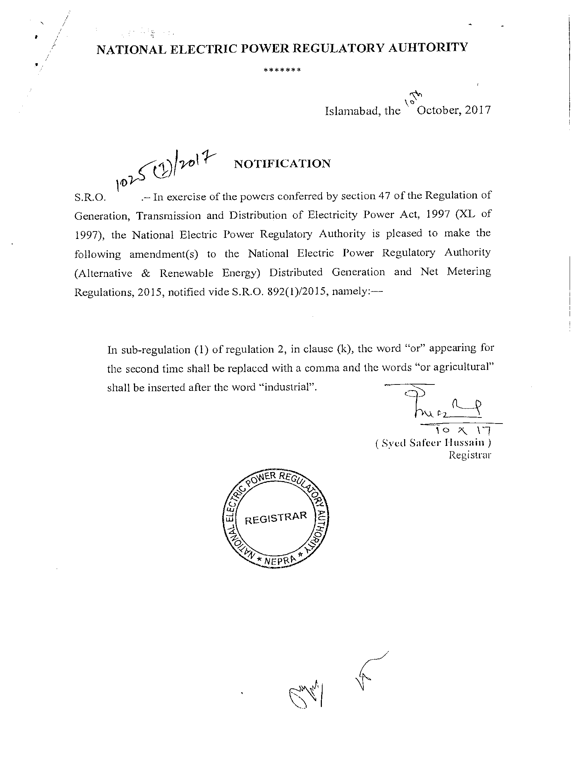

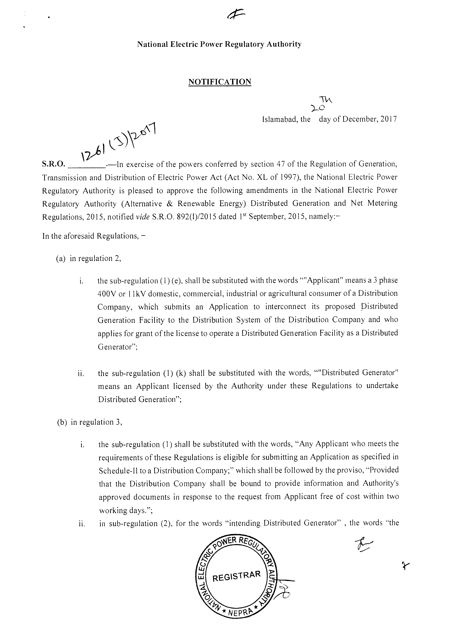

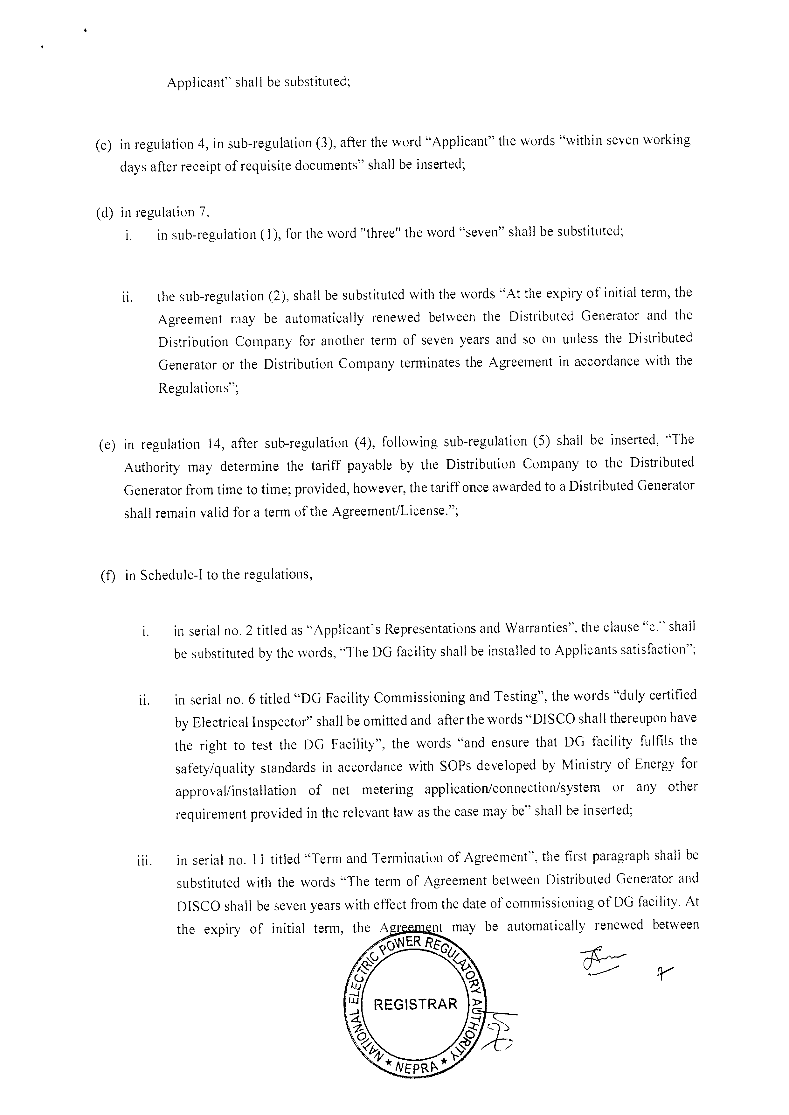
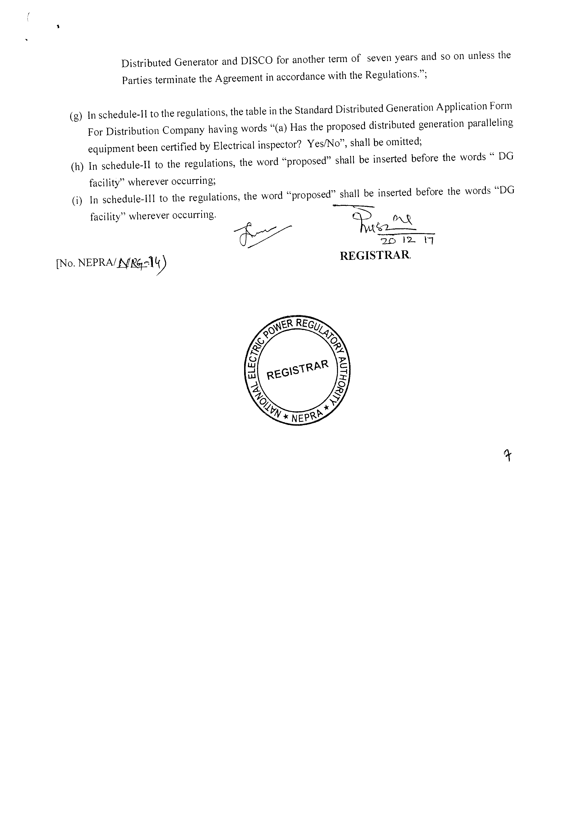

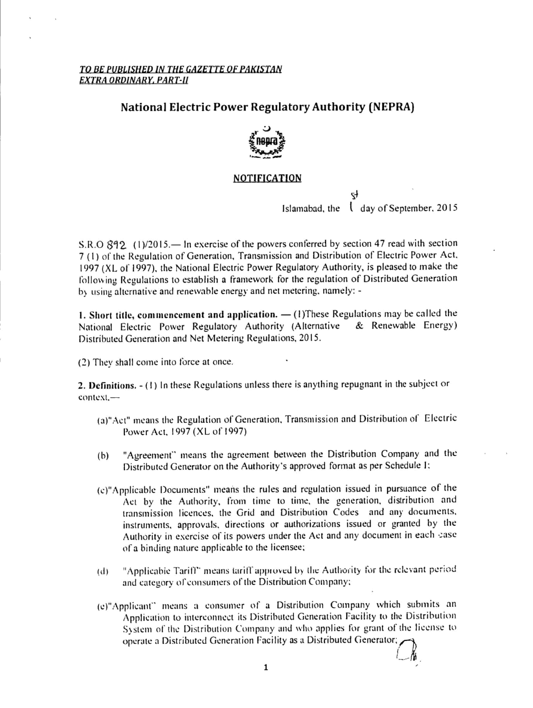

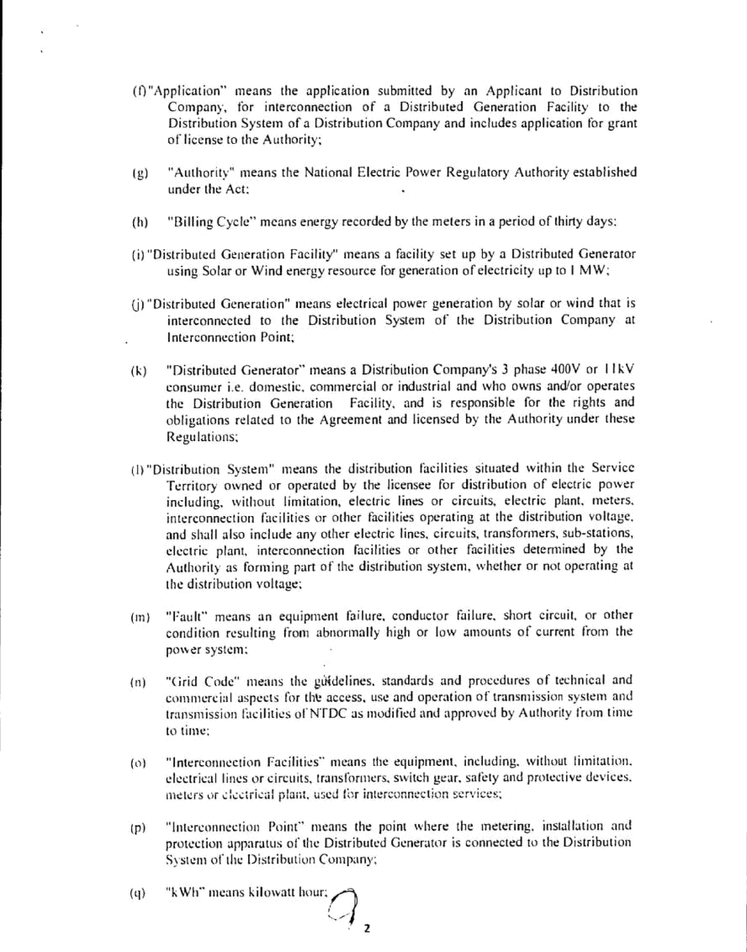

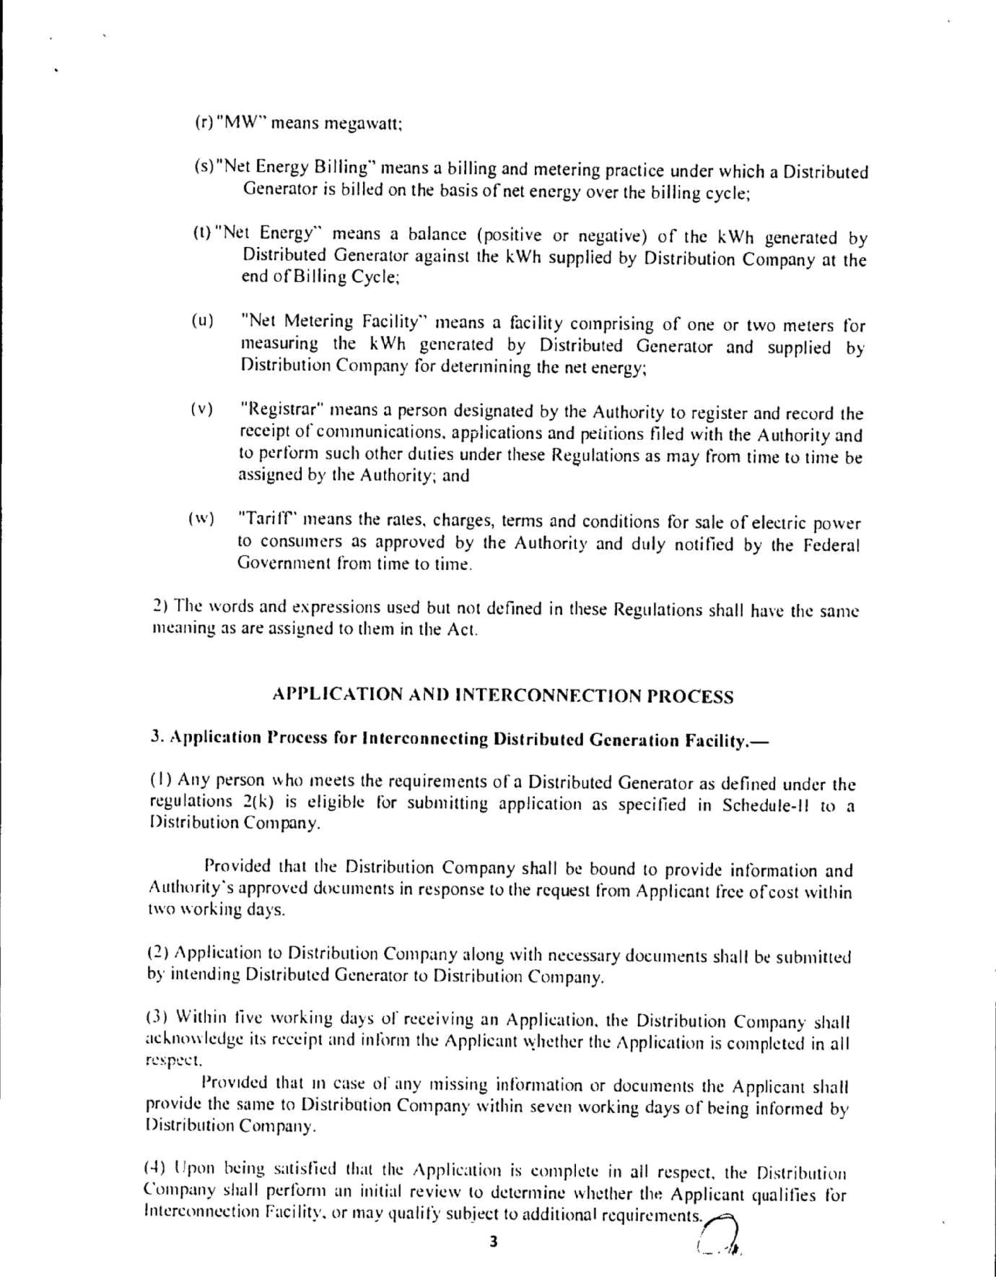

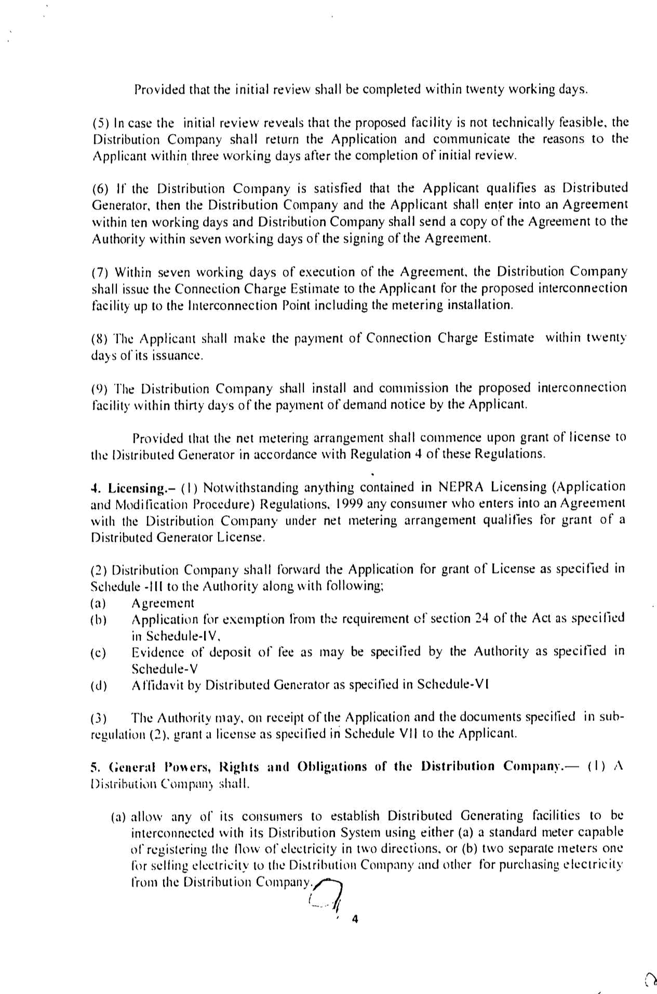

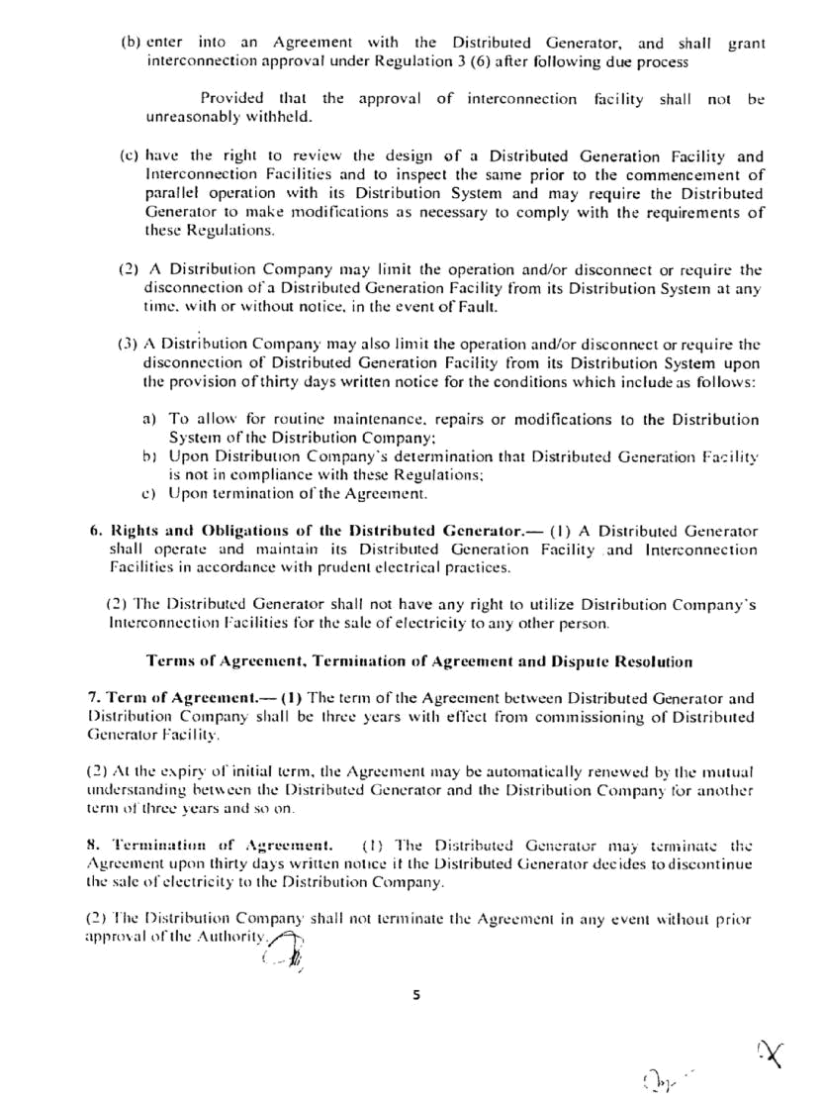

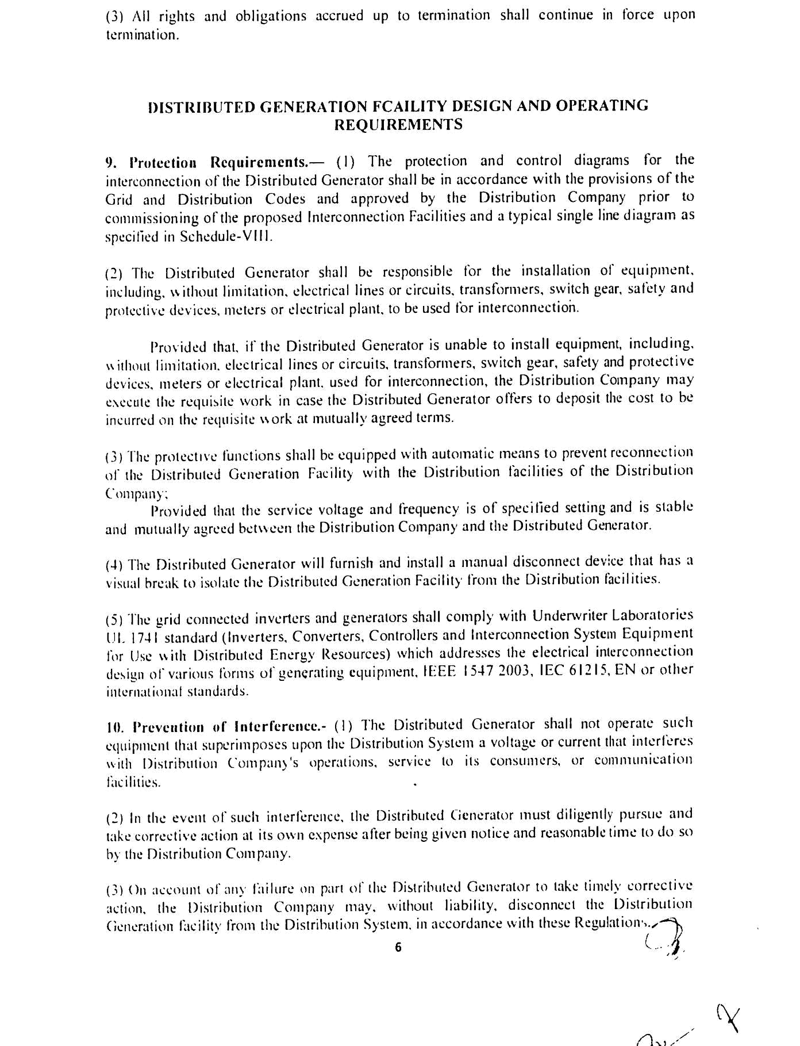

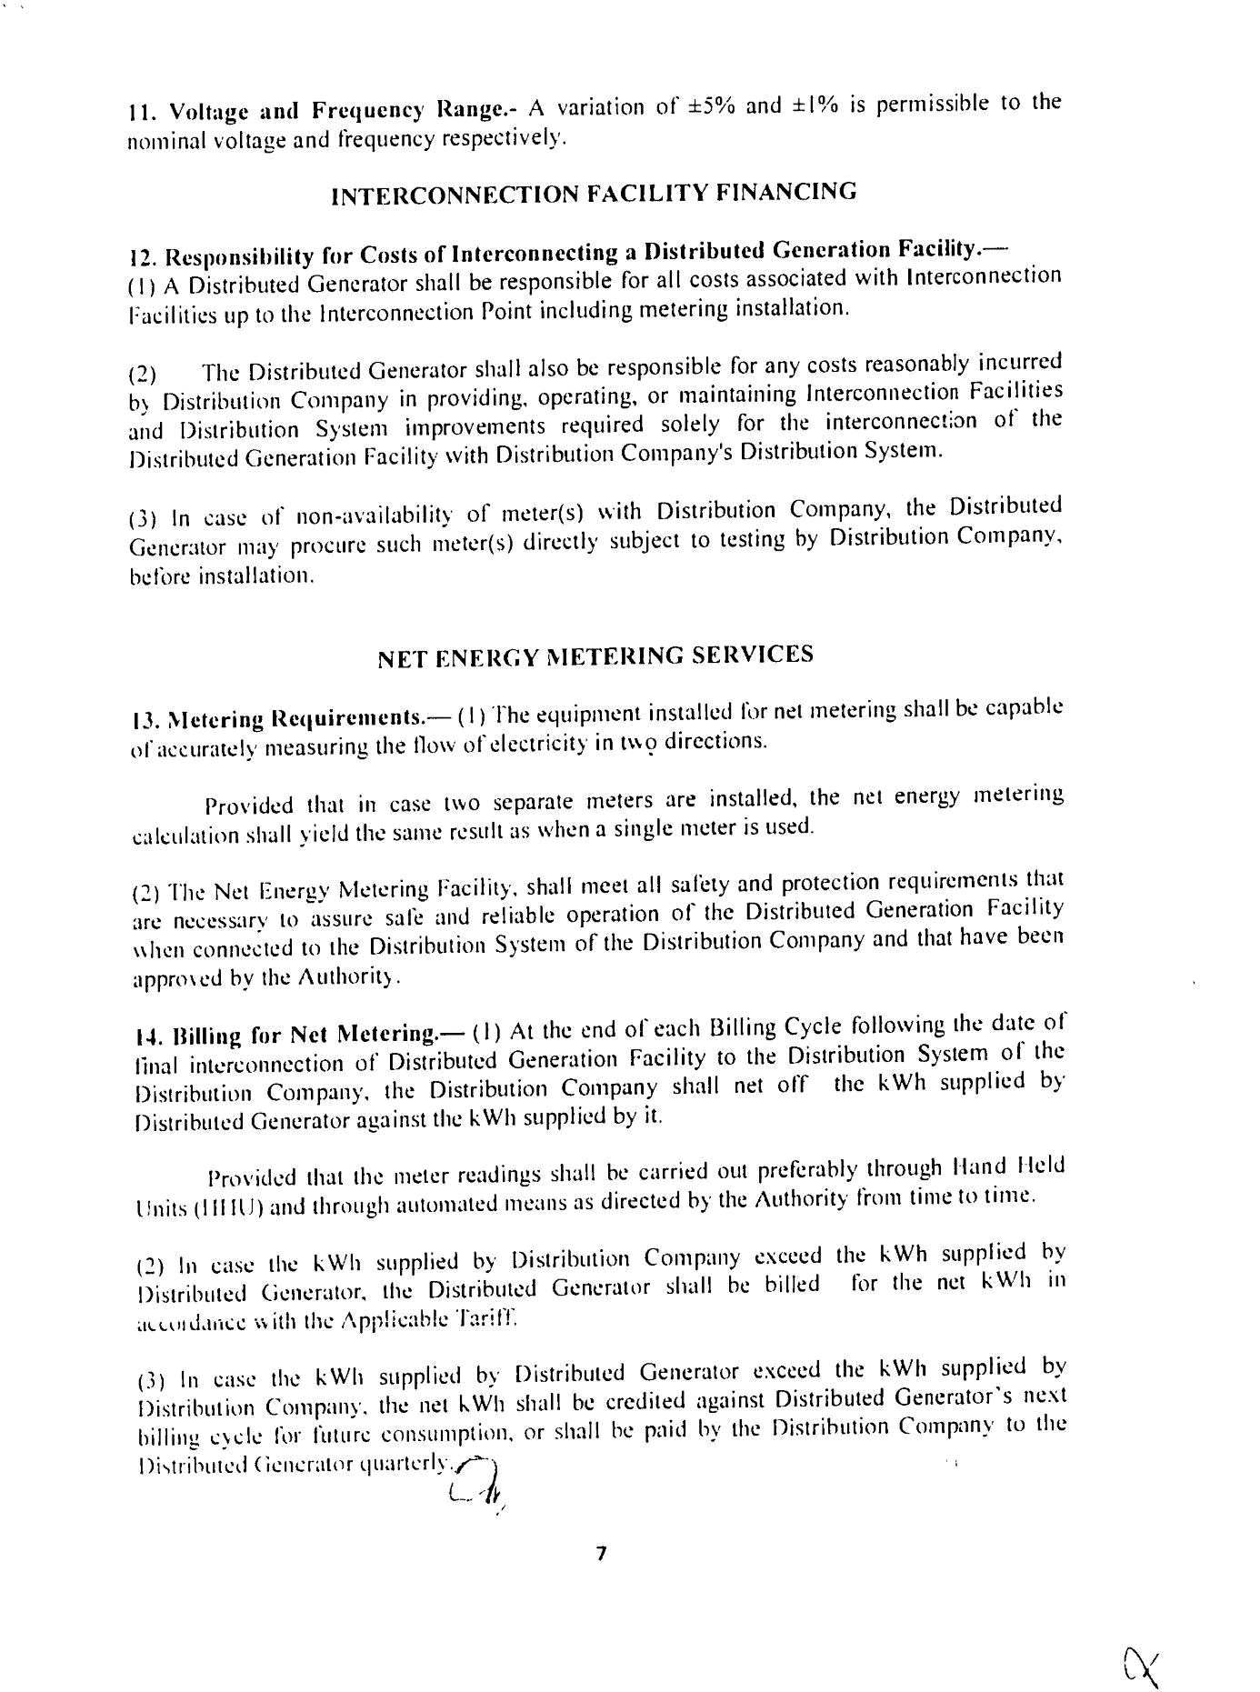

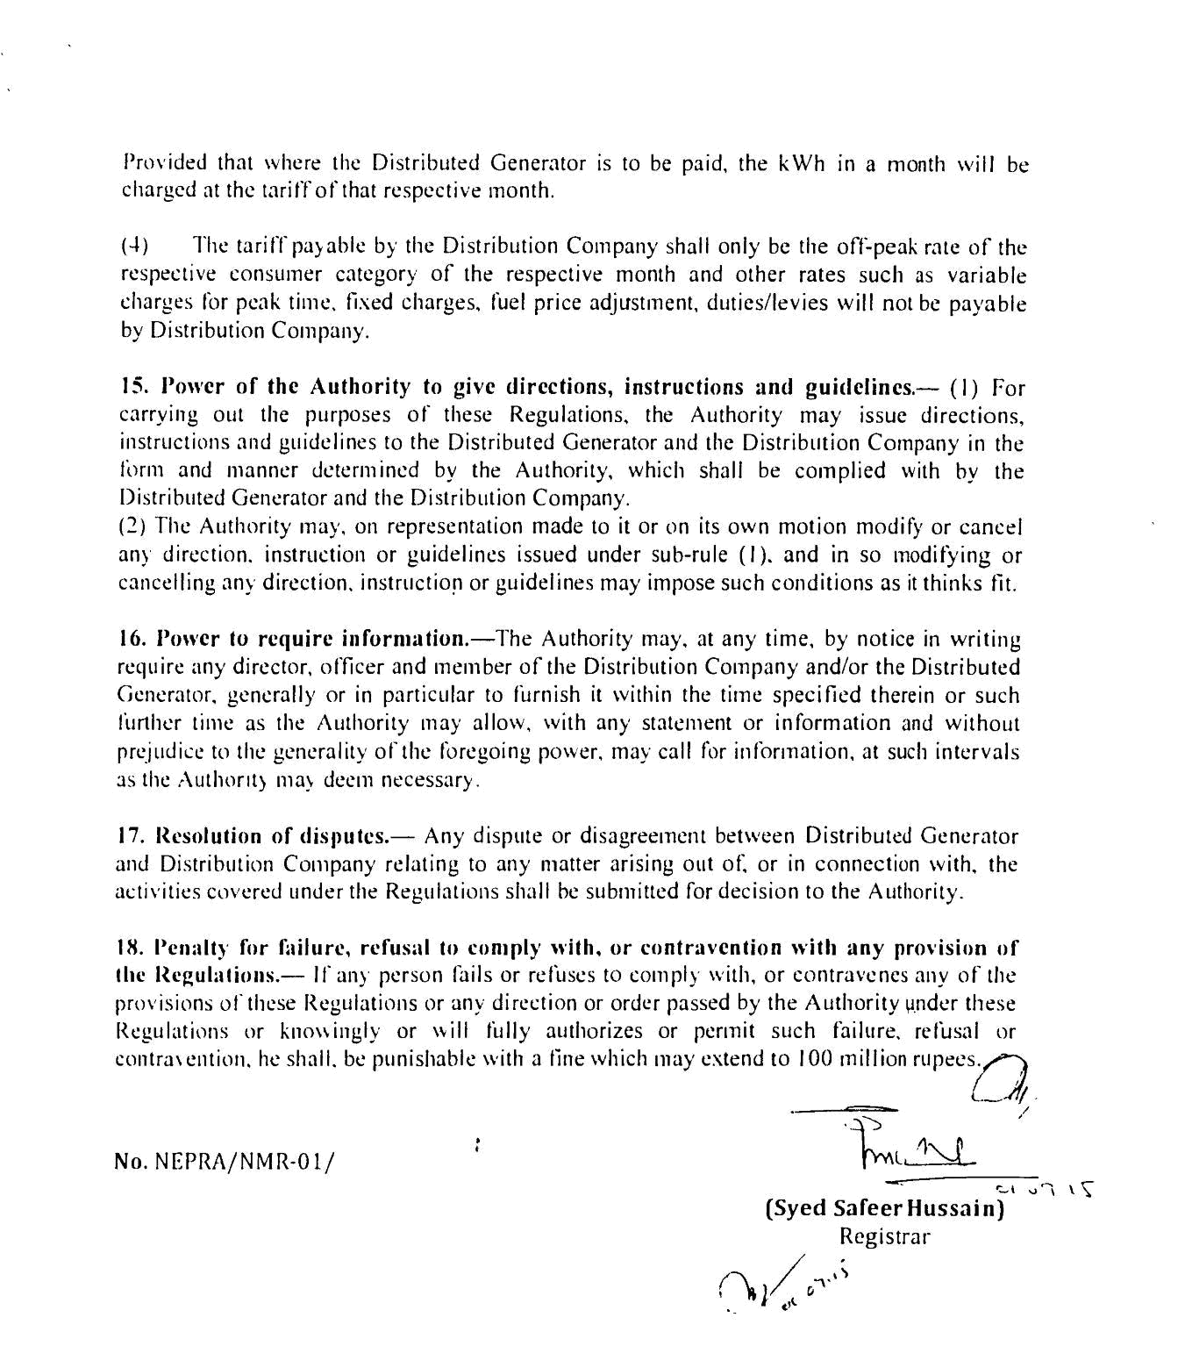

SINGLE LINE DIAGRAM

ON GRID SOLAR ROOFTOP PV SYSTEM

FOR NET METERING INTERCONNECTION

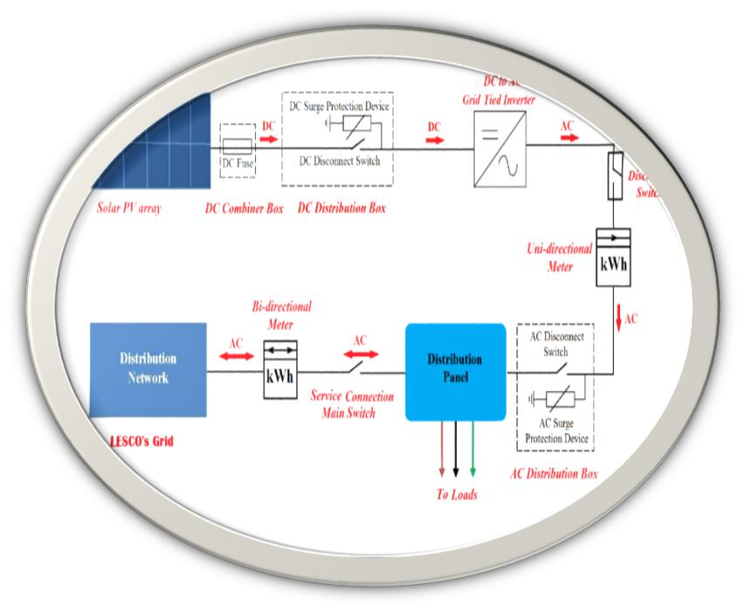

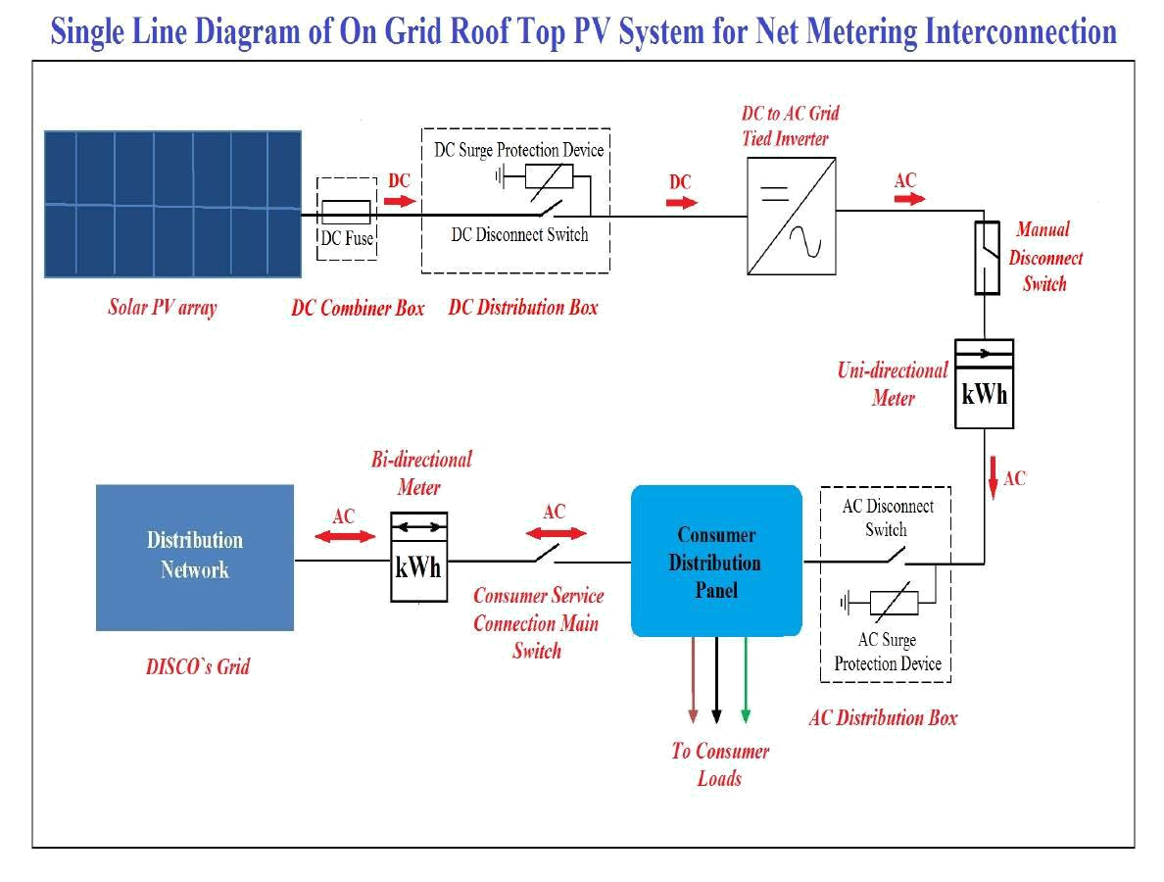

Flow chart of (Solar/Wind Generation) Interconnection Process
MEPCO Net Metering
Application Process
Eligible DG submits application along with required documents in MEPCO Office (Schedule II of Regulations)

MEPCO provides acknowledgement whether application is complete or Not.
NO
If application is incomplete, applicant will provide documents within 7 days.

YES

If application is complete MEPCO performs an initial review to see whether it qualifies for interconnection facility.
Utility Review Process
In case proposed facility is not technically feasible MEPCO informs about reasons of rejection within 3 working days after completion of initial review.
NO
MEPCO performs technical feasibility verification within 20 days.

YES

If facility is technically feasible MEPCO approves installation of SRTPV +& enters into an agreement within 10 days (Schedule-I of Regulations).

Agreement signing and Licensing
MEPCO sends copy of agreement to NEPRA within 7 working days of its signing. MEPCO shall forward the application for grant of License (Schedule-II of Regulations)

Distributed Generator Facility
Solar/Wind energy resource for generation of electricity from 1 KW to 1 MW

MEPCO will issue connection charge estimate within 7 working days of agreement signing.

Applicant shall make payment of estimate within 20 days.

MEPCO shall install/Commission the DG facility within 30 days of payment of Demand Notices.

Eligible Distributed Generator
3 Phase 400V or 11 KV Consumers with proper sanctioned Load as per Solar Generation i.e. Domestic, Commercial, Agricultural or Industrial, who owns operates Distributed Generated Facility

Net Metering shall commence in upon grant license to DG in accordance with in Regulation IV of these regulations.

Billing

The file is sent for Billing

STEPS FOR NET METERING (Solar/ Wind Generation) APPLICATION PROCESS
- Distributed Generator Facility
- Solar/Wind energy resource for generation of electricity from 1KW to 1MW
- Eligible Distributed Generator
- 3 Phase 400V or 11 KV Consumers with proper sanctioned Load as per Solar Generation i.e. Domestic, Commercial, Agricultural or Industrial, who owns operates Distributed Generated Facility
- Eligible DG submits application along with required documents in MEPCO Office (Schedule II of Regulations)
- MEPCO provides acknowledgement whether application is complete or Not.
- If application is complete MEPCO performs an initial review to see whether it qualifies for interconnection facility Or Not.
- If application is incomplete, applicant will provide documents within 7 days
- If application is complete MEPCO performs an initial review to see whether it qualifies for interconnection facility.
- MEPCO performs technical feasibility verification within 20 days.
- In case proposed facility is not technically feasible MEPCO informs about reasons of rejection within 3 working days after completion of initial review.
- If facility is technically feasible MEPCO approves installation of SRTPV +& enters into an agreement within 10 days (Schedule-I of Regulations).
- MEPCO sends copy of agreement to NEPRA within 7 working days of its signing. MEPCO shall forward the application for grant of License (Schedule-II of Regulations)
- MEPCO will issue connection charge estimate within 7 working days of agreement signing.
- Applicant shall make payment of estimate within 20 days.
- MEPCO shall install/Commission the DG facility within 30 days of payment of Demand Notices.
- Net Metering shall commence in upon grant of license to DG in accordance with in Regulation IV of these regulations.
- The file is sent for Billing

TECHNICAL FEASIBILITY, TEST CHECK & INSPECTION
PROFORMAS

Net Metering Technical Feasibility Report
Appendix –A

Inspection / Test Check Performa
Appendix –B

Sample Specifications of Solar Grid Inverter for guidance purpose
Appendix –C

CHECKLIST FOR DG’s GRID SAFETY QUALIFICATION
Appendix –D

Appendix –A

Net Metering Technical Feasibility Report

A. Particulars of the Applicant:
- Name of the Applicant:
- Address:
- Telephone No/Mobile No:
- Email address:
- Reference No. of existing connection
- Sanctioned Load in kW (A):
- Applicable tariff:
- Detail of existing energy meter
- Make and type
- Single / three phase:
b) Capacity in ampere:
c) Direct reading or CT operated:

B. Name of:

- Operation Sub-Division
- Feeder/code
- 132/11.5 KV Grid Station:

C. Details of Distribution Transformer:

- Capacity of Distribution Transformer in KVA (B)
- Voltage ratio of Distribution Transformer
- Solar PV capacity already connected to this Distribution Transformer in KW (C):
- Proposed Solar PV capacity in KW (D):
- Total Solar PV capacity including the proposed new capacity: (E = C + D):

Note: The proposed solar PV capacity addition is technically feasible if

- The total solar PV capacity (E) in kW is not more than 80% of the Distribution Transformer capacity in KVA (B) [E <= B x 80%] and

- The proposed solar PV capacity in kW (D) does not exceed the sanctioned load of the service connection in kW (A) [D <= A].

D. Feeder Details (Applicable for the HT consumers applied for LT connectivity).

- Name of the feeder/code
- Name of Grid Station from which the feeder is emanating with voltage ratio
- Type and size of the conductor
- Current carrying capacity of the feeder
- Maximum load reached on the feeder in KW
- Total connected Distribution Transformer capacity on this 11KV feeder(KVA)
- SPV generators connected on this feeder, if any, and their capacity in KW.

E. Conclusion:
Whether it is technically feasible to connect the proposed solar PV system to the service connection (Yes or No):
Deputy Manager (Operation)___________ Deputy Manager (M&T)________

Appendix –B

Inspection / Test Check Performa

A. Service Connection Details:

- Name of the Consumer:
- Address:
- Telephone No/Mobile No:
- Email address:
- Reference No. of existing connection
- Applicable tariff:
- Details of already existing (removed energy meter)

- Make and type
- Meter Readings
- Serial number
- Month / year of manufacture

B. Details of the Newly Installed Bidirectional Meter

- Make and type
- Serial number
- Month / year of manufacture
- Capacity:
- Meter constant (for CT-operated meters):
- Import register reading (kWh):
- Export register reading (kWh):
- Accuracy ………….

C. Solar Generation Check
- Make and type
- Serial number
- Month / year of manufacture
- KWH Reading
- Meter constant (for CT-operated meters):
- Accuracy…………

D. Solar Grid Inverter
- Make:
- Serial number:
- Capacity:
- Input DC voltage range:
- Output AC voltage range:
- Anti-Islanding Protection Check - if the grid fails the status of the contactor (on or off)

E. Solar PV modules

Total capacity of solar modules (kW):

Deputy Manager (Operation)__________ Deputy Manager (M&T)________

Appendix –C

Sample Specifications of Solar Grid Inverter for guidance purpose

Total output power (AC) | To match solar PV plant capacity while  achieving optimum system efficiency
Input DC voltage range | As required for the solar grid inverter DC input.
Maximum power point (MPPT) tracking | Shall be incorporated
Number of independent MPPT inputs | 1 or more
Operation AC voltage | Single phase 280V or Three phase 415V (+ 12.5%, -20%)
Operating Frequency range | 47.5 – 52.5 Hz
Nominal frequency | 50 Hz
Power factor of the inverter | >0.98 at nominal power
Total harmonic distortion | Less than 3%
Built-in Protection | AC high / low voltage; AC high /low frequency
Anti-islanding protection | As per VDE 0126-1-1, IEC 60255.5 / IEC 60255.27
Operating ambient temperature range | -10ºC to +60 ⁰C
Humidity | 0 – 95% Rh
Inverter efficiency  Inverter weighted efficiency | >=95%  >=94%
Protection degree | IP 65 for outdoor mounting, IP 54 for
Communication interface | RS 485 / RS 232 / RJ45
Safety compliance | IEC 62109-1, IEC 62109-2
Environmental Testing | IEC 60068 - 2 (1,2,14,80)
Efficiency Measurement Procedure | IEC 61683
Cooling | Convection
Display type | LCD for data display. LCD / LED for  status display
Display parameters to include | Output power (W), cumulative energy  (Wh), DC voltage (V), DC current (A),  AC voltage (V), AC frequency (Hz), AC  current (A), cumulative hours of operation (h).

Note:

Inverter Standards

Inverter should comply with IEC 61683 for efficiency and measurements and should comply IEC 60068 -2 (1, 2, 14, 80) / Equivalent BIS standard for environmental testing.

Inverter should supervise the grid condition continuously and in the event of grid failure (or) under voltage (or) over voltage, solar system should be disconnected by the circuit breaker/auto switch provided in the inverter.

Appendix –D
MULTAN ELECTIRIC POWER COMPANY
CHECKLIST FOR DG’s GRID SAFETY QUALIFICATION

1.0. Solar RTPV – Customer and Location Data
1 | Customer Name
2 | Address
3 | Customer Contact - Email
4 | Customer Contact – Mobile No.
5 | DG Installer – Name & Address
6 | MEPCO Officer in Charge
2.0 Component Inspection Checklist
Sr. No | Item Type | YES | NO
1 | Installation layout – is it as per drawing?
2 | Inverter IEC standards qualified
3 | PV panel / DG IEC standards qualified
4 | PV isolators / PV cables IEC standards qualified
5 | AC disconnect manual switch provided
6 | Meters checked by M&T
7 | Any other critical component IEC standards certified
3.0Grid Functional Safety Checklist
Sr. No | Item Type | YES | NO
1 | Check-PV Inverter and islanding (utility side)  Disconnect Grid and check whether PV generator seizes Generation immediately
2 | Check Reconnect time Reconnecting the Grid, PV Generator reconnects minimum 60 seconds later (Single Phase) or minimum 800 seconds later (three Phase connectivity)
3 | Bi directional flow recorded on MEPCO Meter
4 | Consumption (import) only mode OK?
5 | PV inverter anti islanding tested at array side
6 | Solar Generation meter OK?
7 | Check all earthings provided at ACDB/DCDB/LA

It is certified that the PV installation is qualified to be connected to MEPCO Grid.

Dy. Manager (Operation)
______Division MEPCO

List of Approved Vendors for Net Metering

a) 18a List of Provisionally Approved Vendor Installers Service Providers under category ARE V1

b) 18b List of Approved Vendors Installers Service Providers for Net Metering up to 250 KW under Category ARE V2

c) 18c List of Provisionally Approved Vendor Installer Service Provider under category ARE C1 as Consultant Firm for Net Metering


List of Certified Companies under AEDB Certification Regulation 2018
(Certification of Vendors/Installers/Service Providers for Installation of Wind and Solar PV Systems for Net Metering up to 250 KW capacity)
CATEGORY ARE-V2
 | S.No. | Certification No. (Prov.) |  | Company Name |  | Address |  |  | Contact Details
 | 1. | B/3/1/Net Met/JDA/17/11 |  | M/s JD Aviation Sourcing & Engineering Services |  | BF-1, MID City Apartment Khokhar Road |  |  | Tel:  051-4578427  Email:  Jdaviation.sourcing@gmail.com
 | 2. | B/3/1/Net Met/MASCO/17/07 |  | M/s MASCO Energy Services |  | 12/1 – Sector 23 Korangi Industrial Area, Karachi |  |  | Tel:  021-35069471  042-37511851-3  Email:  info@mascoenergy.com
 | 3. | B/3/1/Net Met/SSL/17/10 |  | M/s Solar Sigma Limited |  | 31-A Solar Sigma Centre PWD Society Islamabad |  |  | Tel:  051-5421006 0301-5356635  Email: info@solarsigma.com
 | 4. | B/3/1/Net Met/PEPL/17/16 |  | M/s Pantera Energy |  | Office#1, 2nd Floor, Prism Arcade 2, Midway, Phase 7, Commercial, Bahria Town, Rawalpindi |  |  | Tel:  051-5712099 0337-0422439  Email:  fsaeed@panteraenergy.pk
 | 5. | B/3/1/Net Met/RES/17/03 |  | M/s REON Energy Limited |  | 3RD Floor Dawood Centre, MT Khan Road, Karachi |  |  | Tel:  021-35632200  042-35861050  Email:  info@reonenergy.com
 | 6. | B/3/1/Net Met/ATSE/17/13 |  | M/s ATS Engineering Sales and Services |  | Plot No. 69, Street No. 3, Main Street No. 01, Sector-I 10/3, Islamabad |  |  | Tel:  0345-8778877  0321-5566898  Email:  info@atsengg.com
 | 7. | B/3/1/Net Met/NEPL/17/02 |  | M/s Nizam Energy (Private) Limited |  | G30 / 4, KDA Scheme 05, Block 08, Clifton, Karachi |  |  | Tel:  0300-8250564  0345-5877772  Email:  sales@nizamenergy.com
 | 8. | B/3/1/Net Met/RPL/17/17 |  | M/s RESOLV (Private) Limited |  | 248-C Commercial Broadway Phase 8, DHA, Lahore |  |  | Tel:  0322-4954288  Email: naeem.sheikh@resolvltd.com
 | 9. | B/3/1/Net Met/CEPL/17/09 |  | M/s Creative Electronics (Private) Limited |  | 1601S , Quaid-e-Azam Industrial Estate, Lahore |  |  | Tel:  042-35298601  0321-6461566  Email:  Khuzaima.aslam@hotmail.com
 | 10. | B/3/1/Net Met/JBPL/17/41 |  | M/s Jaffer Brothers (Private) Limited |  | 8 S, Mushtaq Ahmed Gurmani Road, Gulberg II, Lahore |  |  | Tel:  021-111527527 Email:  Omer.zulfiqar@jaffer.com
 | 11. | B/3/1/Net Met/AYK/17/01 |  | M/s AYK (Private) Limited |  | Alsharif Market Main Model Town Road, Gujranwala. |  |  | Tel:  0553-255800  0321-6456446  Email:  info@ayk.com.pk
 | 12. | B/3/1/Net Met/STPL/17/05 |  | M/s Solar Tech (Private) Limited |  | 3rd Floor, PACE (DAMAS) Mall, MM Alam Road, Gulberg-II, Lahore. |  |  | Tel:  042-35778380  0311-9898222  Email:  info@solartech.com.pk
 | 13. | B/3/1/Net Met/TIPL/17/25 |  | M/s Tesla Industries (Private) Limited |  | Plot#81-G, St. 6, I-10/3, Islamabad. |  |  | Tel:  051-4441404  Email: info@tesl-PV.com
 | 14. | B/3/1/Net Met/STS/17/27 |  | M/s SPEL Technology (Private) Limited |  | 127-S, Quaid-e-Azam Industrial Estate, Kotlakhpat Township, Lahore |  |  | Tel:  042-35115506/07  Email:  nhyder@spelgroup.com
 | 15. | B/3/1/Net Met/ZSPL/17/35 |  | M/s Zorays SMC (Private) Limited |  | 70-D, CCA, Phase V, DHA, Lahore Cantt, Lahore |  |  | Tel:  042-37182320 0324-8163264 Email:  zorays@zorays.com
 | 16. | B/3/1/Net Met/MES/17/34 |  | M/s Msquare R Engineering Services |  | 148, D-Block, Faisal Town, Lahore |  |  | Tel:  042-35221414 045-35160099  0323-9631333  Email:  info@msquarer.com
 | 17. | B/3/1/Net Met/ASPL/17/22 |  | M/s Allied Solar (Private) Limited |  | 33 Usman Block, New Garden Town, Lahore |  |  | Tel:  0321-4295675 042-35843541/42  Email:  info@alliedsolar.pk
 | 18. | B/3/1/Net Met/KKB/17/15 |  | M/s K.K.B (Kaim Khani & Brothers) |  | A-27, Block-13/A, Gulshan-e-Iqbal, Karachi. |  |  | Tel:  021-34981182 / 021-34981187  Email:  Kkb_engcon@yahoo.com
 | 19. | B/3/1/Net Met/GPPL/17/38 |  | M/s Greaves Pakistan (Private) Limited |  | Modern Motor House, Beaumont Road, Karachi |  |  | Tel:  021-35682565/67 042-36362241/2  Email:  greaves@gfg.com.pk
 | 20. | B/3/1/Net Met/AEPL/17/24 |  | M/s Al-Bario Engineering (Private) Limited |  | 91-C, Model Town, Lahore |  |  | Tel:  042-111001954  Email:  aepl@aepl.com.pk
 | 21. | B/3/1/Net Met/KHS/17/23 |  | M/s KHS (Kaiynat Hitech Services) |  | Plaza 2A, Street 20, Sector F-11/2, Suleiman Market, Islamabad |  |  | Tel:  051-8735373/4 0324-3876527  Email:  info@khs.com.pk
 | 22. | B/3/1/Net Met/TPPL/17/19 |  | M/s Trillium Pakistan (Private) Limited |  | 10th Floor, AWT Plaza, The Mall, Rawalpindi |  |  | Tel:  051-5524181/2 Email:  mail@trillium-pakistan.com
 | 23. | B/3/1/Net Met/SREPL/17/18 |  | M/s SRE (Siddique Renewable Energy) (Private) Limited |  | 47 GT Road Hide Market, Lahore |  |  | Tel:  042-36883600  042-37164533  Email:  info@sre.com.pk
 | 24. | B/3/1/Net Met/PITCO/17/04 |  | M/s PITCO (Private) Limited |  | 2nd Floor Al-Maalik, 19 DEVAS Road, Lahore |  |  | Tel:  042-36313235/36  Email:  net.metering@pitcopk.com
 | 25. | B/3/1/Net Met/PEPL/17/06 |  | M/s Premier Energy (Private) Limited |  | 42 E/1 Ghalib Road Gulberg, Lahore |  |  | Tel:  042-111234235  091-5603171  Email:  info@premierenergy.com.pk
 | 26. | B/3/1/Net Met/CEPL/17/31 |  | M/s Catkin Engineering Sales and Services (Private) Limited |  | Plot # 140, Street # 09, I-10/3, Islamabad |  |  | Tel:  051-4100081/82  Email:  Naseer.ahmad@catkin.com.pk
 | 27. | B/3/1/Net Met/TSK/17/08 |  | M/s TSK Engineering Intl. (Private) Limited |  | 54-A Small Industrial Estate, Jamrud Road, Peshawar, Pakistan |  |  | Tel:  091-5830596  0346-8595614  Email:  tskpakistan@yahoo.com
 | 28. | B/3/1/Net Met/RS/17/12 |  | M/s Renewable Stars (Private) Limited |  | House 10, Street 135, Sector G-13/4, Islamabad. |  |  | Tel: 051-2301183  Cell: 0345-5063979  Email: info@renewablestars.com
 | 29. | B/3/1/Net Met/HISEL/17/28 |  | M/s HISEL Power Pakistan (Private) Limited |  | 35 Ahmad Block New Garden Town Lahore |  |  | Tel:  042-35940088  Email:  info@hiselpower.com
 | 30. | B/3/1/Net Met/NCPL/17/30 |  | M/s Nascom Construction (Private) Limited |  | 66-L, Gulberg III, Lahore |  |  | Tel:  042-35846291/4  Email:  Info@nascom.com.pk
 | 31. | B/3/1/Net Met/HSPL/17/36 |  | M/s Hadron Solar (Private) Limited |  | Office No. 326, Johar Avenue, New Canal Road, Lahore |  |  | Tel:  042-35240526 Email:  info@hadronsolar.com
 | 32. | B/3/1/Net Met/IPS/17/42 |  | M/s Inverex Power Solution |  | Shop No 1-A, Jubilee Mansion Shahra-E-Liaquat, Regal, Saddar, Karachi |  |  | Tel:  021-32701145 021-32750760/63  Email:  info@inverexpower.com
 | 33. | B/3/1/Net Met/EEPL/17/20 |  | M/s Ercon Energy (Private) Limited |  | 22 Km, Off Ferozepur Road, Rohi Nala, Opp. Comfort, Goffet Unit 2, Gate 2, Lahore |  |  | Tel:  042-35260321  Email:  info@erconenergy.com
 | 34. | B/3/1/Net Met/RP/17/43 |  | M/s Renewable Power |  | Plot No. 3A, Industrial Estate, Jamrud Road, Peshawar |  |  | Tel: 091-5891549 0333-9019787 Email:  renewablepower@live.com
 | 35. | B/3/1/Net Met/JKSPL/17/46 |  | M/s JKS (Private) Limited |  | Suit No. 7, 3rd Floor, Al-Latif Center, Main Boulevard, Gulberg-III, Lahore. |  |  | Tel: 042-35781317, 35781111  Fax: 042-35781110  Email: ali@jks-int.com
 | 36. | B/3/1/Net Met/PH/17/45 |  | M/s Power Highway |  | 5th Floor, Venus Plaza, 7 Egerton Road, Lahore. |  |  | Tel: 042-36370380-81  Email: info@powerhighway.net
 | 37. | B/3/1/Net Met/FBPL/17/52 |  | M/s Four Brothers Energy (Private) Limited |  | 77, D-1, 1st Floor, Lahore Centre, Main Boulevard, Gulberg-III, Lahore. |  |  | Tel: 042-35782691  Fax: 042-35782610  Email: info@4bgroup.com
 | 38. | B/3/1/Net Met/EATPL/17/14 |  | M/s Adaptive Technologies (Private) Limited |  | Suit No. 03, 4TH Floor Dean Arcade BL No. 08, Clifton, Karachi |  |  | Tel:  021-35865897  021-3586044  Email:  info@adaptive-tec.com
 | 39. | B/3/1/Net Met/EBR/17/51 |  | M/s EBR Energy Pakistan (Private) Limited |  | Suite No. 315, Siddiq Trade Centre, Gulberg-II, Lahore. |  |  | Tel: 042-35817340-41  Fax: 042-35817339  Email: info.pak@ebr-energ.com
 | 40. | B/3/1/Net Met/DWPTPL/17/49 |  | M/s DWP Technologies (Private) Limited |  | 5-Zafar Ali Road, Gulberg-V, Lahore. |  |  | Tel: 042-111005006  Fax: 042-35755368  Email: waqar.amer@dwp.com.pk
 | 41. | B/3/1/Net Met/OESPL/17/48 |  | M/s Orient Energy Systems (Private) Limited |  | Plot No. 9, Sector 24, Korangi Industrial Area, Karachi. |  |  | Tel: 021-111507507  Fax: 021-3507710  Email: info@orient-power.com
 | 42. | B/3/1/Net Met/SS/17/32 |  | M/s Smart Sense |  | Office 107, Cubator 1NE, Park Road, Malik Ave, Chak Shehzad, Islamabad |  |  | Tel: 051-2363590 0336-5117795  Email:  sheraznazir@yahoo.com
 | 43. | B/3/1/Net Met/17/47 |  | M/s Dynamic Green (Private) Limited |  | 109-1, Block-C, Model Town, Lahore. |  |  | Tel:  042-35915414  Fax: 042-35915415  Email: junaid.qureshi@ogl.com.pk
 | 44. | B/3/1/Net Met/MAK/17/21 |  | M/s MAK Pumps Company (Private) Limited |  | Plot # 87, Industrial Estate, Jamrud Road, Peshawar |  |  | Tel:  091-5812472/73 Email:  info@makpumps.com
 | 45. | B/3/1/Net Met/ZED/17/33 |  | M/s ZED Solar Limited |  | 34-A, Zafar Ali Road, Gulberg V, Lahore |  |  | Tel:  042-35791190  Email:  info@zedsolar.com
 | 46. | B/3/1/Net Met/AESPL/18/55 |  | M/s Allied Engineering & Services (Private) Limited |  | Allied Centre, Peshawar Road, 2 K.M., Tarnol Railway Crossing, Post Office Tarnol, Islamabad. |  |  | Tel: 051-2227000-04  Fax: 051-2227005  UAN: 051-111-250-250  Email: isb@aesl.com.pk
 | 47. | B/3/1/Net Met/II/18/54 |  | M/s ICEBERG Industries |  | 472-Airline Society, Near University of Central Punjab, Lahore. |  |  | Tel: 042-35229601  Fax: 042-35391876  UAN: 021-111-111-211  Email: info@icebergindustries.net
 | 48. | B/3/1/Net Met/RSPL/18/61 |  | M/s Read Solar (Private) Limited |  | 97/8, Baber Block, New Garden Town, Lahore. |  |  | Tel: 042-35911705  Fax: 042-35911629  Email:  info@readgroup.com.pk

List of Certified Companies under AEDB Certification Regulation 2018
(Certification of Vendors/Installers/Service Providers for Installation of Wind and Solar PV Systems for Net Metering up to 250 KW capacity)
CATEGORY ARE-V2
S.No. | Certification No. (Prov.) | Company Name | Address | Contact Details
1. | B/3/1/Net Met/HMA/17/26 | M/s HMA pumps (Private) Limited | Plot # 1, Sector # 05, Korangi Industrial Area, Karachi. | Tel:  0334-5148444  0340-8668296  Email:  Rsm.rwp@hmapumps.com
2. | B/3/1/Net Met/ZEPL/17/29 | M/s ZEUS Energy (Private) Limited | Office#4, Ground Floor, Evacuee trust Complex Agha khan Road, F-5/1, Islamabad | Tel:  051-28707777  Email:  sales@zeus.com.pk
3. | B/3/1/Net Met/FEW/17/37 | M/s Festoon Engineering Works | Office No. 03, Clock Plaza Chowk, Ghanta Ghar, Multan | Tel:  061-4501995  Email: festoonengineering@gmail.com
4. | B/3/1/Net Met/EE/17/39 | M/s EMCON Engineering | 501-A, Panorama Centre, Building No. 02, Raja Ghazanfar Ali Khan Road, Karachi | Tel:  021-35218611  Email:  emcon@cyber.net.pk
5. | B/3/1/Net Met/SEPL/17/40 | M/s Solution Engineering (Private) Limited | Solution’s Tower, 95-A, DHA, Phase-8, Lahore | Tel:  042-111419687 Email:  Nadeem.malik@solutions.com.pk
6. | B/3/1/Net Met/ASL/17/44 | M/s Akhter Solar Limited | House # 310, Aurangzeb Road, Sector E-7, Islamabad | Tel:  051-2656651/2 Email:  sales@akhtersolar.com
7. | B/3/1/Net Met/CSUN/17/50 | M/s CSUN Energy Pakistan (Private) Limited | Shop No. 103, Situated Floor, Edentower, Gulberg-III, Gulberg Town, Lahore. | Cell: 0312-3951527  Email: jingyu.sun@csun-power.com
8. | B/3/1/Net Met/SEPL/18/59 | M/s Sky Electric (Private) Limited | 15th Floor, Islamabad Stock Exchange Tower, 55-B, Blue Area, Islamabad. | Tel: 051-8487480-99  Email:  www.skyelectric.com
9. | B/3/1/Net Met/NEPL/18/58 | M/s Nanx Engineering (Private) Limited | 1st Floor, Al-Awan Tower, Plaza No. 5, Jinnah Blvd West, Sector-A, DHA Phase II, Islamabad. | Tel: 051-2723537  Email:  info@nanx.com.pk
10. | B/3/1/Net Met/PSPL/18/60 | M/s Peakworx Systems (Private) Limited | Peakworx Building, E379, Qainchi Amer Sidhu, Ferozpur Road, Lahore. | Tel: 042-35820605  Email:  zgillani@peakworx.biz
11. | B/3/1/Net Met/SOLIS/18/62 | M/s Solis Energy Solutions (Private) Limited | C-18, Block 4, Clifton,  Karachi. | Tel: 021-35876531-5  Email: www.solis-energy.com
12. | B/3/1/Net Met/ZSPL/17/63 | M/s Zi Solar (Private) Limited | 67, Street No. 23, Khayaban-e-Badban,  Phase-V, DHA,  Karachi. | Tel: 021-35244298  Fax: 021-35851895  Email: info@zisolar.com.pk  Web: www.zisolar.com.pk

INSPECTION OF ELECTRICAL INSTALLATIONS

for Commissioning/ Energization for inter connection of D.G. facility with the distribution system of disco for net-metering.


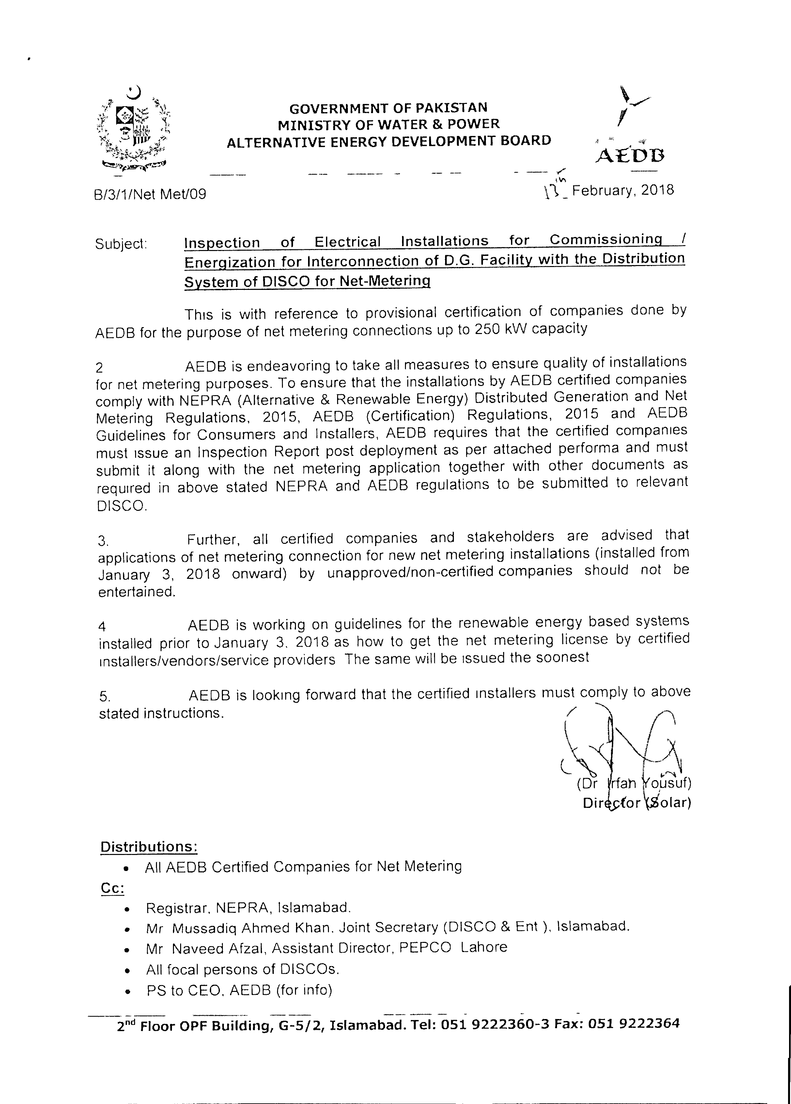
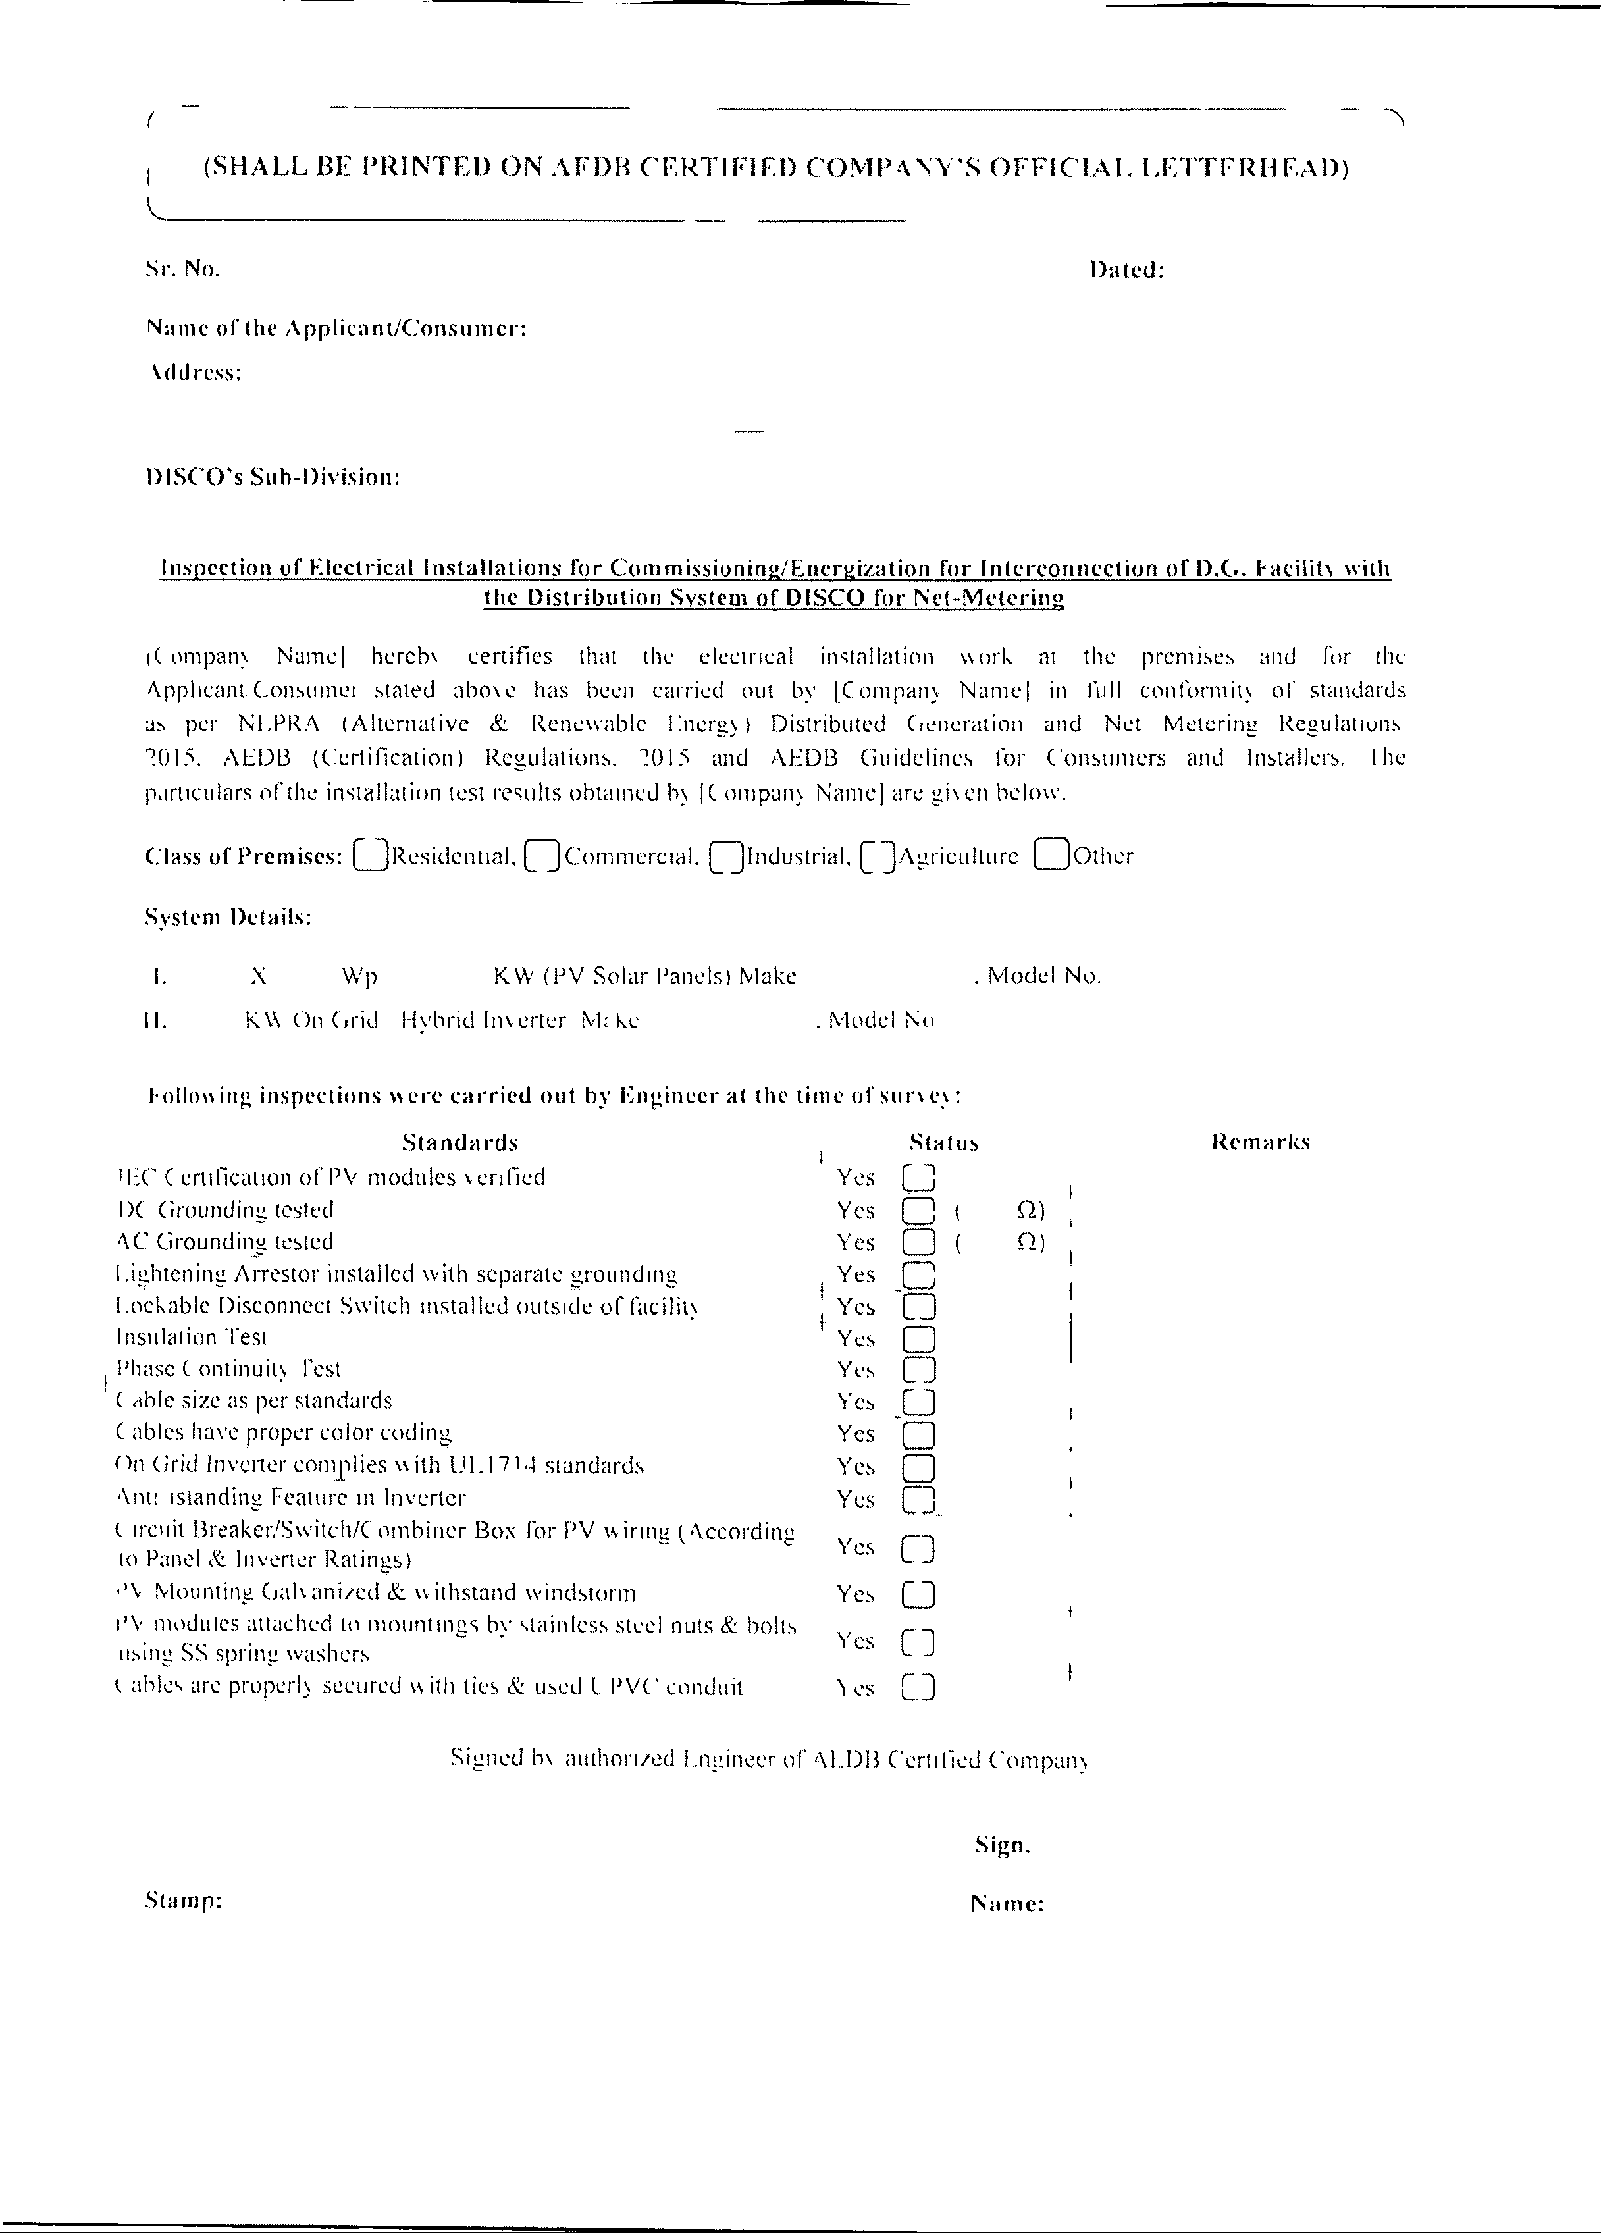

Soft Copy can be downloaded from:
- www.mepco.com.pk (Sr.No. 15 for MEPCO Net Metering Guide or search Google)
- Also download NEPRA notifications From Net Metering tab of www.mepco.com.pk
a)SRO 1025(I)2017 10-10-2017.PDF
b)Amendments in Net Metering SRO 1261(I)2017
c)NEPRA Notification-SRO No.-892-2015
- Please download AEDB Approved Vendors List for Installation of Solar System from Net Metering tab of www.mepco.com.pk or www.aedb.org
- http://www.aedb.org/articles-list/268-list-of-provisionally-approved-applicants-for-net-metering-under-aedb-certification-regulation-2017
- http://www.aedb.org/ju-elibrary/distributed-generation /net-metering-reference-guide-for-the-discos

Comments / Suggestions (if any) may be communicated through:

Email ID:
powersystempk@gmail.com

Phone No.: 0330-8088418

*************************
Compiled by: Muhammad Rehan Khan
(Addl. A.M Computer Operations)
0333-6175707, 0302-7475120, 0312-9659359
*************************
Net Metering Cell,
MEPCO HQ, Khanewal Road Multan
************************



FAQs: FREQUENTLY ASKED QUESTIONS ABOUT NET METERING

http://mepco.com.pk/net-metering-mepco
Q1. What is Net-Metering? +
Q2. How does Net-Metering Work? +
Q3. How long does the processing of a Net Metering application take? +
Q4. Who is eligible for net metering? +
Q5. How is it possible to meter my export? +
Q6. I am a tenant and I wish to install rooftop solar PV system; am I allowed? +
Q7. I am not a consumer of MEPCO, can I apply for net metering? +
Q8. What is Vendor pre-qualification? +
Q9. How do I know that my vendor is an approved installer? / Where can I find the list of approved vendors for installing net metering system?
Q1 0. Is there any limit to the solar PV system size? +
Q1 1. Can I add more solar panels to any existing system? +
Q1 2. How much net metering is allowed in MEPCO? +
Q1 3. If I have multiple meters at my location, how am I supposed to apply? +
Q1 4 Can my exported units be adjusted against a different meter on the same premise?
Q1 5 .Should I buy and own the Solar PV system? +
Q1 6. What is the electric grid? +
Q1 7. Are there any specific vendors for installing my PV system for Net +
Metering?
Q1 8.How do I know that my solar PV system is eligible for Net Metering? +
Q1 9. What will be the process if I already have a solar PV system installed at the premises?
Q20. If I want to discontinue Net Metering Service, what should I do? +
Q21. Can MEPCO disconnect my Net Metering Service?

ANSWERS
Q1. What is Net-Metering?
Answer Q1:
Net metering is an electricity policy for consumers who own Renewable Energy facilities which allows them to use electricity whenever needed while getting credit for contributing their production to the grid.

Producing electricity partly for own consumption, and partly for sale to the DISCO, is now available in the Pakistan. Solar and Wind Energy is a long term power solution. The Solar PV Technology gives access to affordable electricity supply during system life. Residential and commercial customers can switch their electricity load to Solar/Wind energy and can slash their power bills.

Q2. How does Net-Metering Work?
Answer Q2:
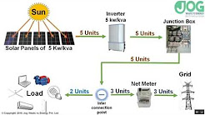

This picture illustrates the flow of electricity from power generation via high voltage transmission and distribution utilities to the end-user who can now install a renewable energy facility and send the not needed electricity back to the distribution grid and earn credit for his export.

The most common answer to the first question – what happens when solar panels generate more electricity than the homeowner can use during the day – is that, in an area that has net metering, the excess electricity flows back to the grid to serve nearby neighbors while your meter essentially runs backwards.

Q3. How long does the processing of a Net Metering application take?
Answer Q3:Application Processing

Within in five working days of receiving an application the DISCO shall acknowledge its receipt and inform the applicant whether the application is complete in all respect. This includes verification of arrear if any, spot inspection by the inspection committee and submission of technical feasibility report to be prepared by the Inspection committee.

While preparing the Technical Feasibility of proposed interconnection Inspection Committee shall keep in view following checks:

- The sanctioned DG load on any T/F should not be more than 80% of its capacity.
- To check whether the proposed interconnection will require upgrading the capacity of existing distribution network.
- Phase balancing has to be checked to avoid unbalancing of load in secondary circuit of distribution line.
In case of any missing information or document, the Applicant shall provide the same to the DISCO Office within seven working days of being informed by the office.

The DISCO’s Office shall perform an initial review to determine whether the Applicant qualifies for Interconnection Facility, or may qualify subject to additional requirements. Provided that the initial review shall be completed within twenty working days.

In case the initial review reveals that the proposed facility is not technically feasible, the DISCO's Office shall return the Application and communicate the reasons to the Applicant within three working days after the completion of initial review.

If the DISCO's Office is satisfied that the Applicant qualifies as Distributed Generator, and an approval in writing from Provincial Electric Inspector as mentioned in Clause 6 of Schedule I appended to the Regulation has been submitted by the Applicant, the DISCO's Office and the Applicant shall enter into an Agreement (as per schedule-I of Regulation) within ten working days and DISCO’s Office shall send a copy of the Agreement to the NEPRA within seven working days of the signing of the Agreement. The DISCO's office shall forward the Application for grant of License as specified in Schedule -III of the Regulation, to the Authority along with followings;

- Agreement
- Application for exemption from the requirement of section 24 of the Act as specified in Schedule-IV,
- Evidence of deposit of fee as may be specified by the Authority as specified in Schedule-V
- Affidavit by Distributed Generator as specified in Schedule-VI

Within seven working days of execution of the Agreement, the DISCO’s Office shall issue the Connection Charge Estimate to the Applicant for the proposed interconnection facility up to the Interconnection Point including the metering installation.

The Applicant shall make the payment of Connection Charge Estimate within twenty days of its issuance and will intimate the office in writing.

The Disco office Shall install and commissioned the proposed interconnection facility within thirty days of the payment of demand notice by the applicant Provided that the net metering arrangement shall commence upon grant of license to the Distributed Generator in accordance with Regulation 4 of these Regulations

Q4. Who is eligible for net metering?
Answer Q4:
Any person who meets the requirements of a Distributed Generator as defined under the Regulations 2(k) is required to submit application (as specified in Schedule-II of Regulations duly filled along with necessary documents) in the office relevant DISCO’s focal person.

Q5. How is it possible to meter my export?
Answer Q5:
A single bi-directional service connection meter shall be installed to measure import and export (kWH) separately. For existing service connections, the uni-directional service connection meter shall be replaced with a bi-directional service connection meter. Bi-directional service connection meter accuracy and facilities shall be the same as applicable to the standard uni-directional meters for the relevant type of service connection and tariff.
Q6. I am a tenant and I wish to install rooftop solar PV system;
am I allowed?
Answer Q6:
- The applicant is required to install the DG Facility through system installer who has experience in design, supply and installation of DG Facility.
- The DG Facility should comply with the relevant IEC technical standards.
- The installation work has to be carried out as per the approved drawing and as per standards.
In case the installed (also read proposed) capacity of the DG Facility is higher than the sanctioned load of the consumer, which consequently requires an up-gradation in the infrastructure (service line meter with CT (if required), transformer upgrading (if required)), the consumer will have to upgrade at his / her / its own cost.

Q7. I am not a consumer of MEPCO, can I apply for net metering?
Answer Q7:
If you are not a consumer of MEPCO, you cannot apply for net metering. Apply to your respective Disco where you are getting your electricity facility.

Q8. What is Vendor pre-qualification?
Answer Q8:
For details Click on Link below
AEDB Certification Regulations 2018
Q9. How do I know that my vendor is an approved installer? / Where can I find the list of approved vendors for installing net metering system?

Answer Q9:
List of Provisionally Approved Companies under AEDB Certification Regulation 2017 is provided on AEDB website.
(Certification of Vendors/Installers/Service Providers for Installation of Wind and Solar PV Systems for Net Metering up to 250 KW capacity)
For more details Click on link below:
List of Approved (provisionally) vendors / installers / service providers for Net Metering under AEDB (Certification) Regulation, 2017

Q10. Is there any limit to the solar PV system size?
Answer Q10:
limit to the solar PV system size is 1 KW to 1000 KW.

Q11. Can I add more solar panels to any existing system?
Answer Q11:
a:If your sanctioned load more than your installed capacity then you can add more solar panels to any existing system before applying and DG License is obtained later, after enhancing the solar panels and inverter should have the capacity to flow the installed load of electricity.
b: To increase the DG facility NEPRA license and invertors must also be enhanced.
Q12. How much net metering is allowed in MEPCO?
Answer Q12:

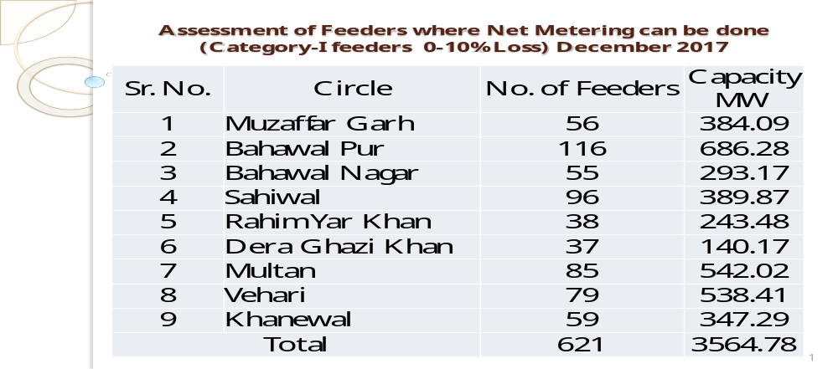

Q13. If I have multiple meters at my location, how am I supposed to apply?
Answer Q13:
If you have multiple meters at your location, You can apply on that 3 Phase connection which is to be connected with solar system.
Q14. Can my exported units be adjusted against a different meter on the same premise?
Answer Q14:
No your exported units only be adjusted against the same meter where DG facility is obtained on the same premise.

Q15 .Should I buy and own the Solar PV system?
Answer Q15:
Yes you can buy and own yours Solar PV system from any AEDB approved vendors. Click on the following link.
List of Approved (provisionally) vendors / installers / service providers for Net Metering under AEDB (Certification) Regulation, 2017
Q16. What is the electric grid?
Answer Q16:An electrical grid is an interconnected network for delivering electricity from producers to consumers.
An electrical grid is an interconnected network for delivering electricity from producers to consumers. It consists of generating stations that produce electrical power, high voltage transmission lines that carry power from distant sources to demand canters, and distribution lines that connect individual customers.^{[1]}
Power stations may be located near a fuel source, at a dam site, or to take advantage of renewable energy sources, and are often located away from heavily populated areas. They are usually quite large to take advantage of economies of scale. The electric power which is generated is stepped up to a higher voltage at which it connects to the electric power transmission network.
The bulk power transmission network will move the power long distances, sometimes across international boundaries, until it reaches its wholesale customer (usually the company that owns the local electric power distribution network).
On arrival at a substation, the power will be stepped down from a transmission level voltage to a distribution level voltage. As it exits the substation, it enters the distribution wiring. Finally, upon arrival at the service location, the power is stepped down again from the distribution voltage to the required service voltage(s).
Electrical grids vary in size from covering a single building through national grids which cover whole countries, to transnational grids which can cross continents.
Q17. Are there any specific vendors for installing my PV system for Net Metering?
Answer Q17:Click on the following link.
List of Approved (provisionally) vendors / installers / service providers for Net Metering under AEDB (Certification) Regulation, 2017
Q18.How do I know that my solar PV system is eligible for Net Metering? Answer Q18:
Click on the following link.
Get your system checked by the list of companies attached below link:
List of Approved (provisionally) vendors / installers / service providers for Net Metering under AEDB (Certification) Regulation, 2017
Q19. What will be the process if I already have a solar PV system installed at the premises?
Answer Q19:
Get your system checked by the list of companies attached below link and get the certification of installation from them.
List of Approved (provisionally) vendors / installers / service providers for Net Metering under AEDB (Certification) Regulation, 2017
Q20. If I want to discontinue Net Metering Service, what should I do? Answer Q20:
If you want to discontinue Net Metering Service, Please contact to your concerned XEN MEPCO Ltd. Multan
Q21. Can MEPCO disconnect my Net Metering Service?
Answer Q21:
If you are MEPCO defaulter then your Net Metering Service can be disconnected otherwise not.






